Lab 4 Host Hardening

1 Navigating the Group Policy Management Center

1. Launch the 2012 R2 VM
2. Bring up the login window by sending a Ctrl + Alt + Delete.
3. Log in with credentials provided
4. Close the Server Manager
5. Launch run
6. Once run windows appears type gpmc.msc
7. Expand the trees on the left until you reach Group Policy Objects. (Click on Domains-> CySA.org-> Group Policy Objects.)
8. Leave this window open for the next task
9. Creating New Group Policies
10. In the Group Policy Management Center, right-click Group Policy Objects and click new
11. Name it GPO Password Policy

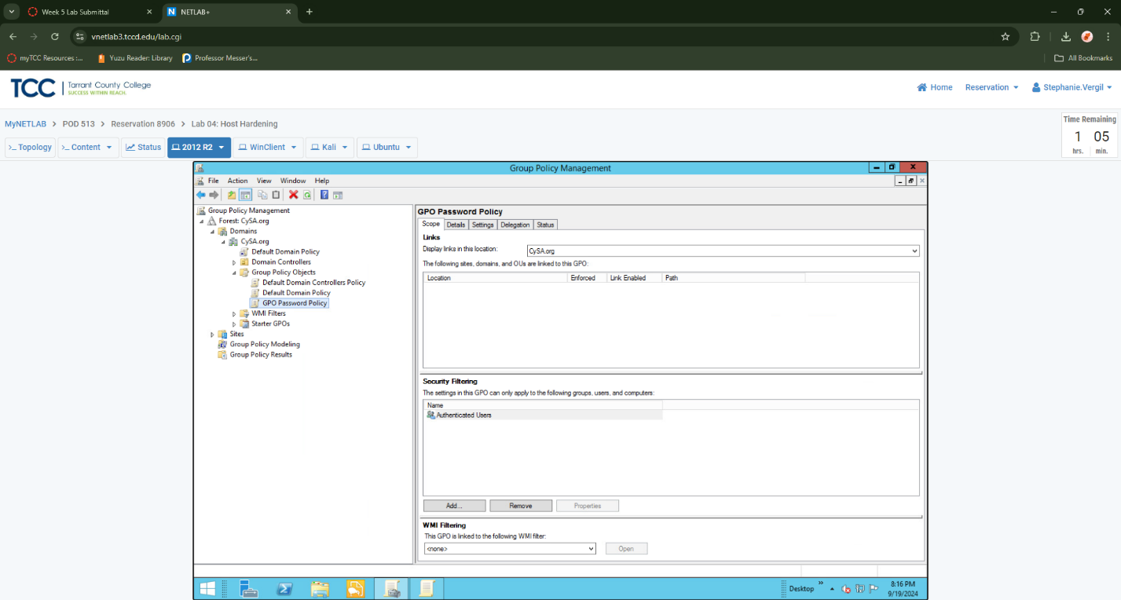

1. Right-click the newly created policy and select Edit
2. Once the Group Policy Management Editor opens, navigate to Computer Configuration-> Policies-> Windows Settings-> Security Settings-> Account Policies and select Password Policy.

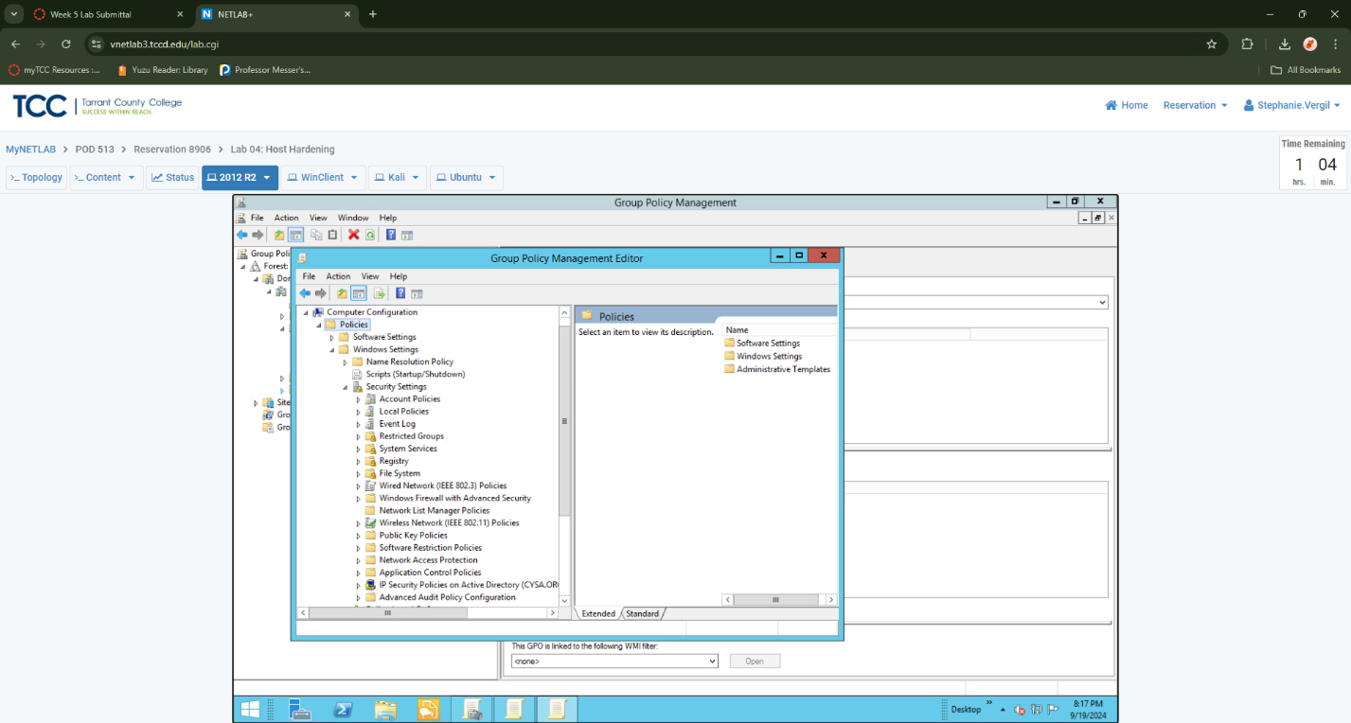

1. Double-click Maximum Password Age
2. In the Maximum password age Properties window, place a check in the box that reads Define this policy setting. In the box that says Password will expire in:, type 90. Click OK.
3. When prompted to automatically set a minimum password age, click OK to continue.
4. Double-click Minimum Password Length.
5. In the Minimum password length Properties window, place a check in the box that reads Define this policy setting. In the box that says Password must be at least:, type 8. Click OK.
6. Double-click on Password must meet complexity requirements
7. In the Password must meet complexity requirements Properties window, place a check in the box that reads Define this policy setting. Click Enabled. Click OK.
8. Review the policies you just created before closing the Group Policy Management Editor. 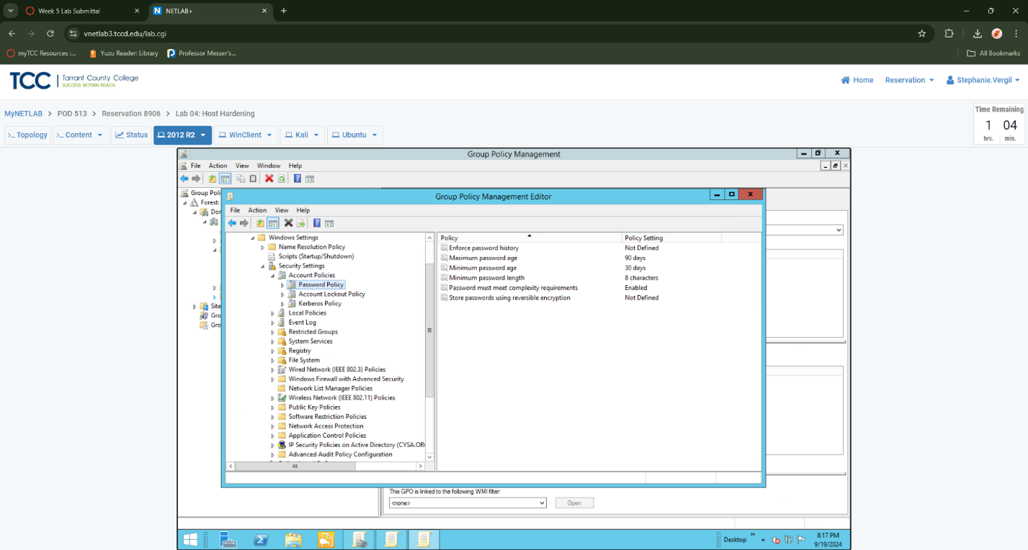
9. To create an Acceptable Use Policy Consent Agreement, right-click Group Policy Objects, and select New.
10. In the Name field, type AUP Consent Agreement and click OK

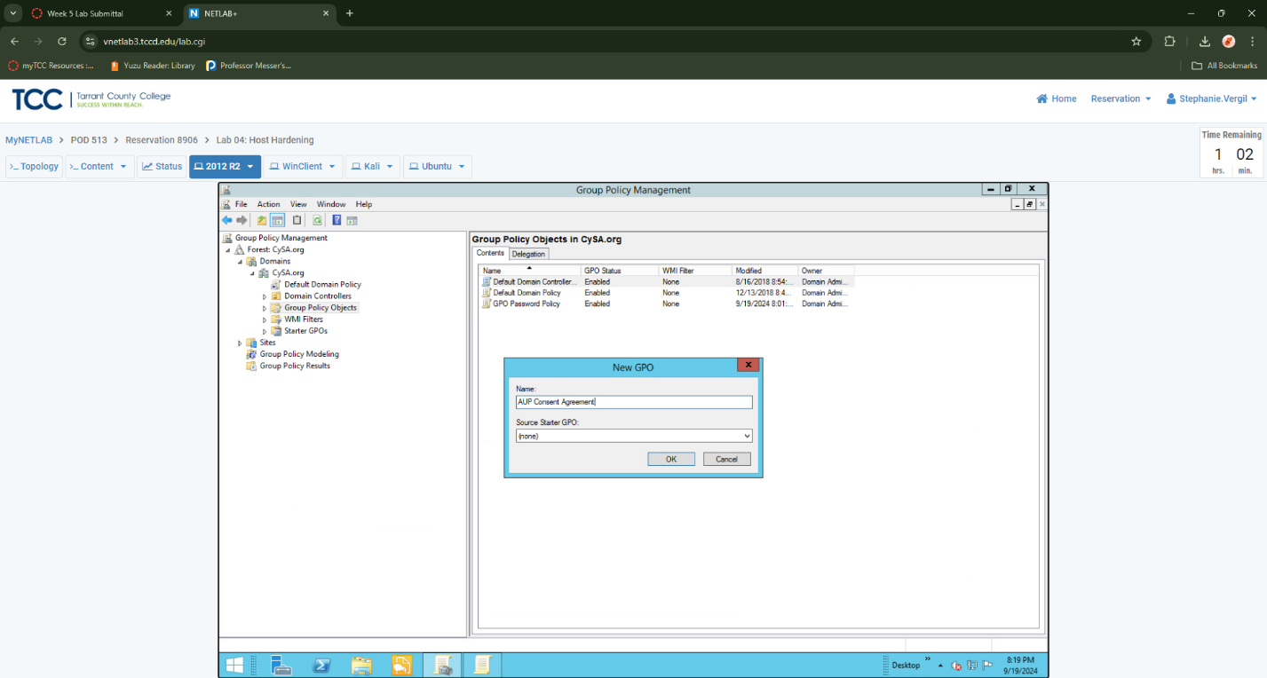

1. Right-click AUP Consent Agreement and select Edit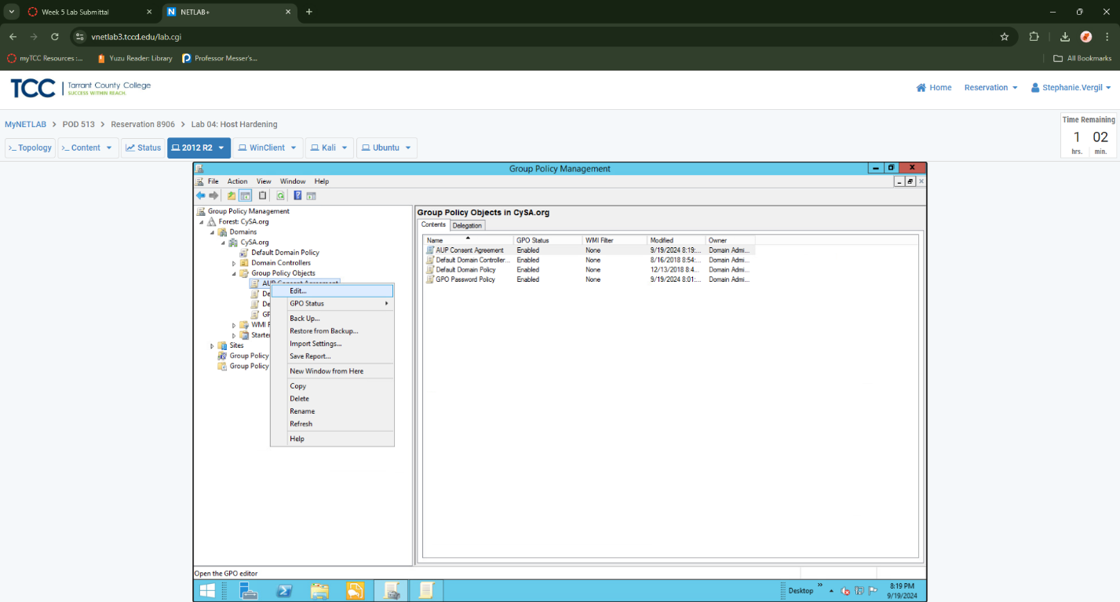
2. In the Group Policy Management Editor, navigate to Computer Configuration-> Policies-> Windows Settings-> Security Settings-> Local Policies-> Security Options.
3. In the right pane, scroll down and double-click Interactive logon: Message text for users attempting to log on.

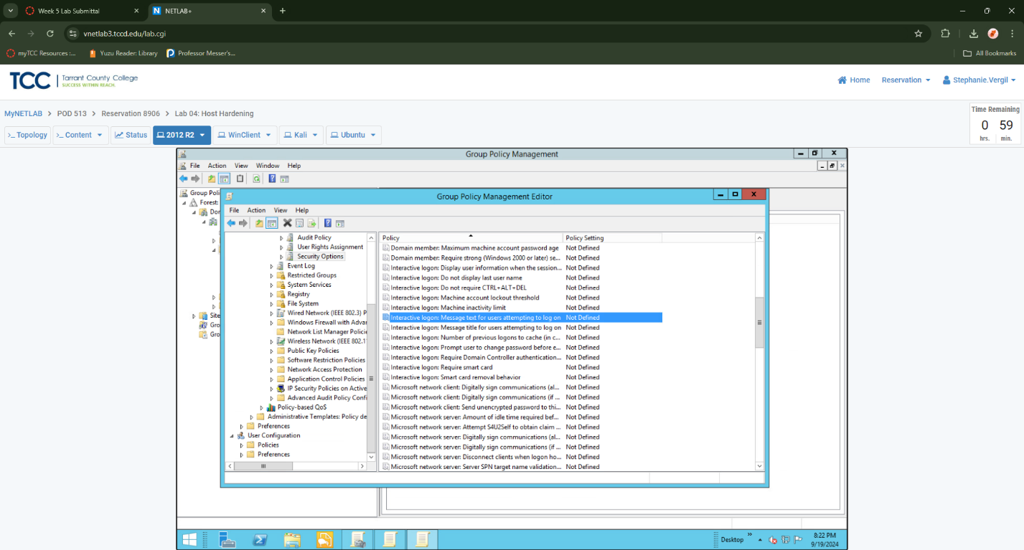

1. In the Interactive logon: Message text for users attempting to log on Properties window, place a checkmark in Define this policy setting in the template. In the box below, type “Unauthorized use of this system is strictly prohibited. Use of this system may be monitored for security and legal purposes. By using this system, you agree to comply with the terms outlined in the Acceptable Use Policy.” Click OK

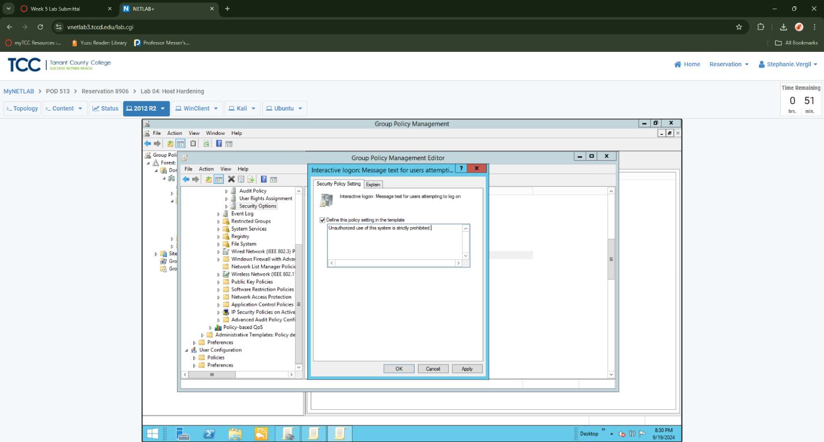

1. In the right pane, double-click Interactive Logon: Message title for users attempting to log on

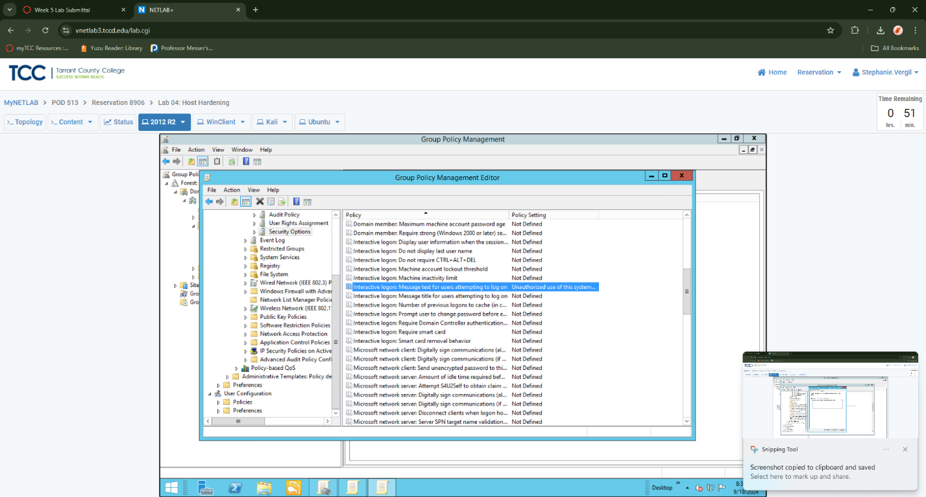

1. In the Interactive logon: Message title for users attempting to log on Properties window, place a checkmark in the Define this policy setting box. In the box below, type AUP Consent Agreement.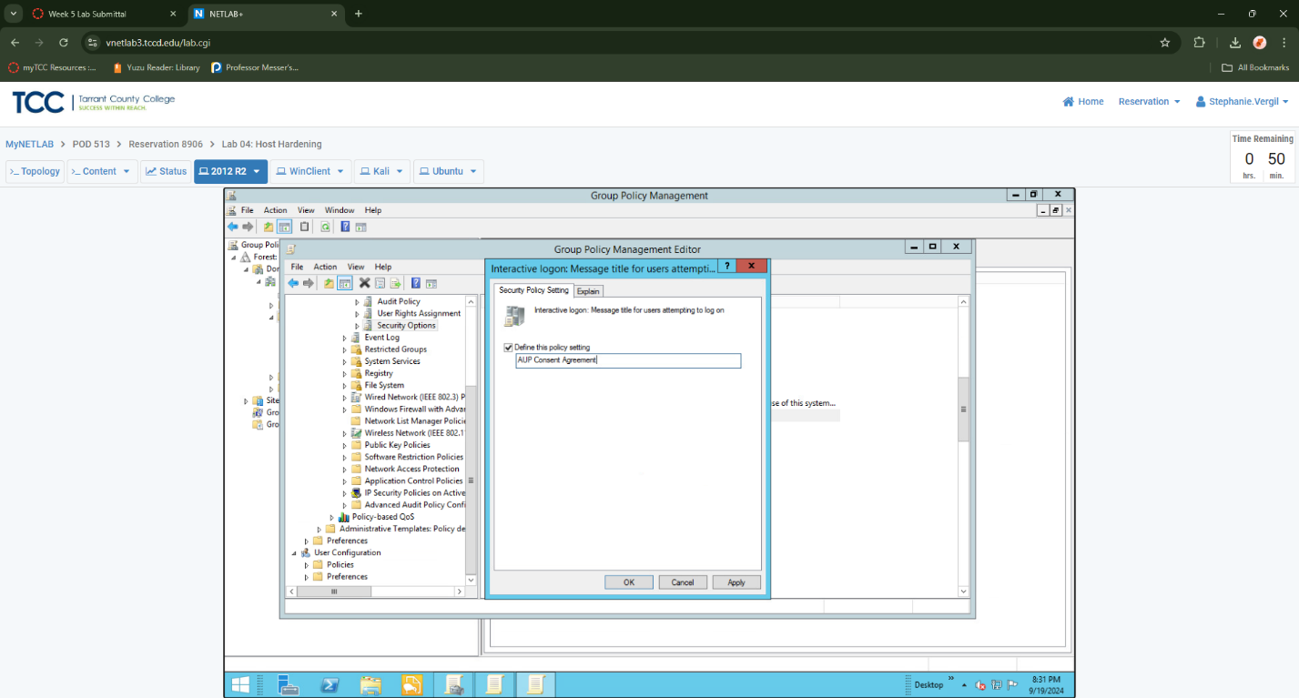
2. Review the settings for the AUP Consent Agreement policy you just created before closing the Group Policy Management Editor

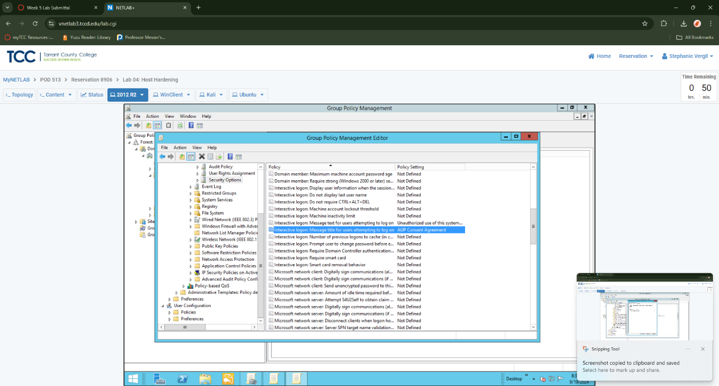

1. In the Group Policy Management Center, click on AUP Consent Agreement. In the right pane, under the Scope tab, click Add in the Security Filtering section, type Everyone in the box and click OK.

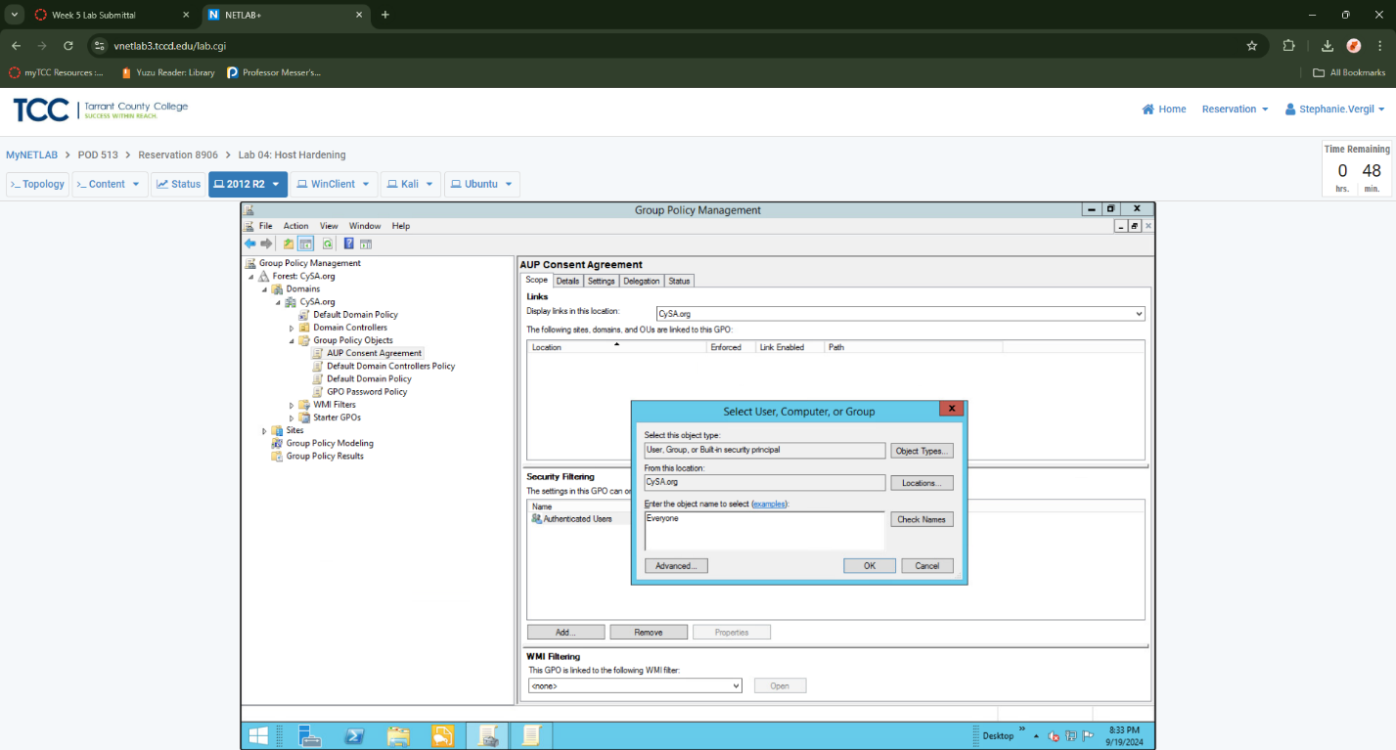

1. Right-click CySA.org in the Group Policy Management Center. Select Link an Existing GPO…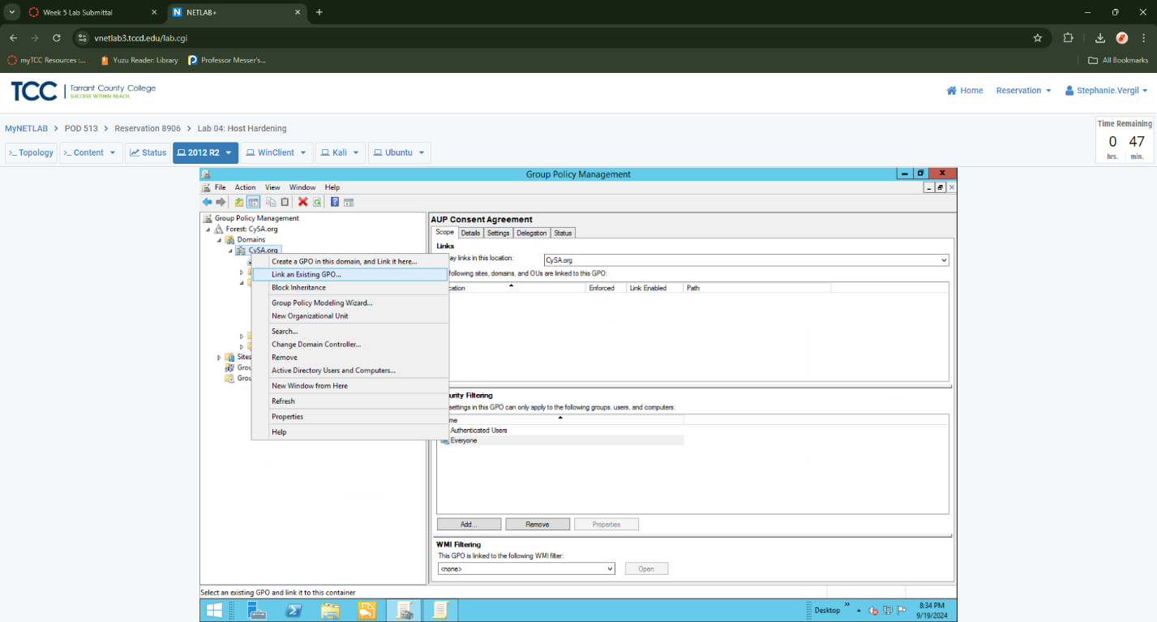
2. Select AUP Consent Agreement and GPO Password Policy by holding the CTRL button and clicking each one. Once selected, proceed by clicking OK.

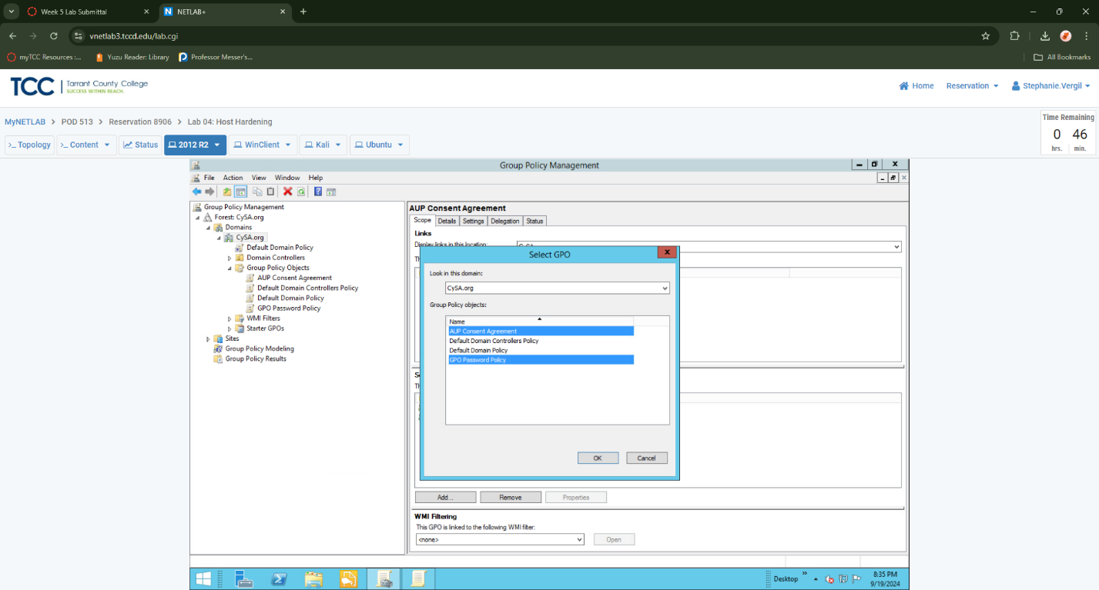

1. Close all windows to navigate to the desktop. In the taskbar, right-click the Windows button-> Shut down or sign out-> Rest

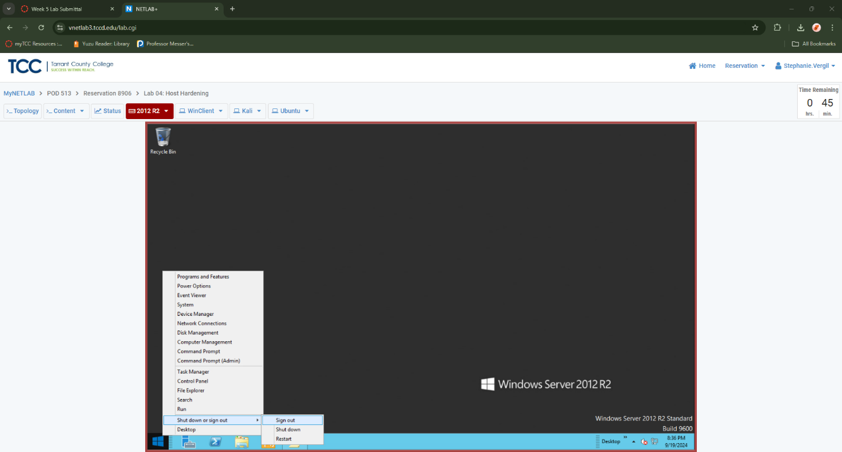

1. Choose Other (Unplanned) and click Continue.
2. Once the computer restarts, send CTRL+ALT+DEL to the 2012 R2 VM. You should be met with the AUP Consent Agreement. Click OK and log in as CySa\Administrator using the password Password123. Once logged in, you may close the Server Manager window.

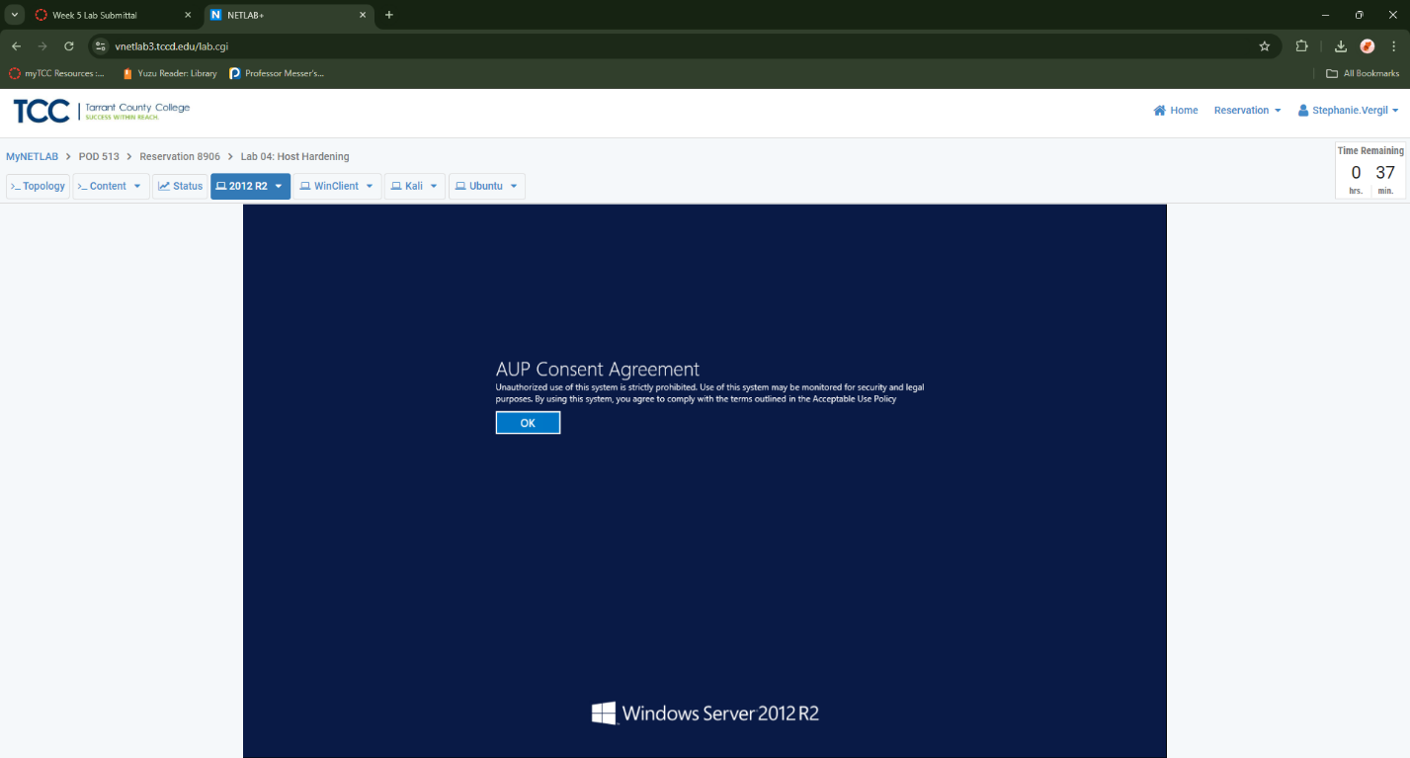

1. Securing Unused Ports
2. Launch the Kali virtual machine to access the graphical login screen.
3. Press ENTER to bring up the login screen. Log in as root using the password toor.
4. Once on the desktop screen, open a Terminal window.
5. In the Terminal, enter the following command to check which ports are open on the 2012 R2 virtual machine: nmap -F 192.168.1.2

From the results, you’ll notice that several ports are open. For this lab, focus on ports 53 and 88, which are used for DNS and Kerberos authentication.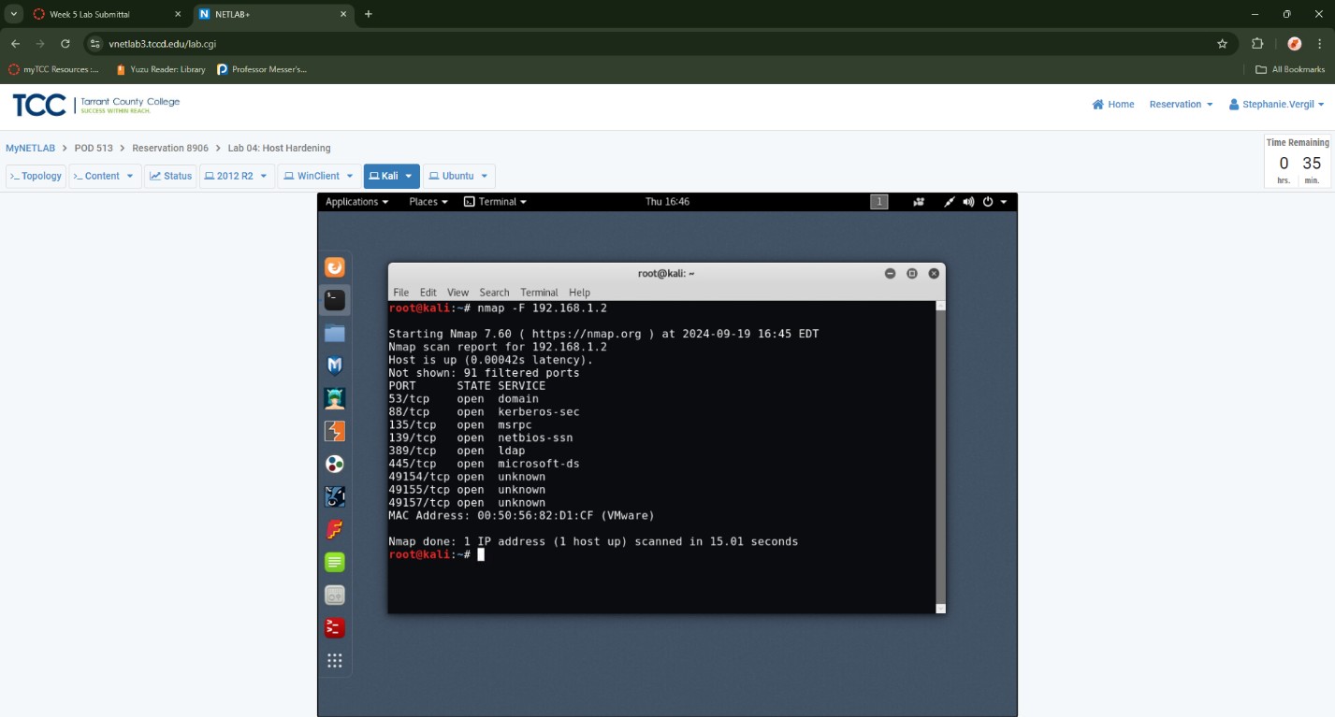

1. Return to the 2012 R2 virtual machine.
2. Move your mouse cursor towards the rop-right corner or the screen for the 2012 R2 VM. Notice options become available. Click on the Search icon
3. Type Firewall to bring up a list of options. These options will automatically populate in the search list as you type. Click on Windows Firewall with Advanced Security.

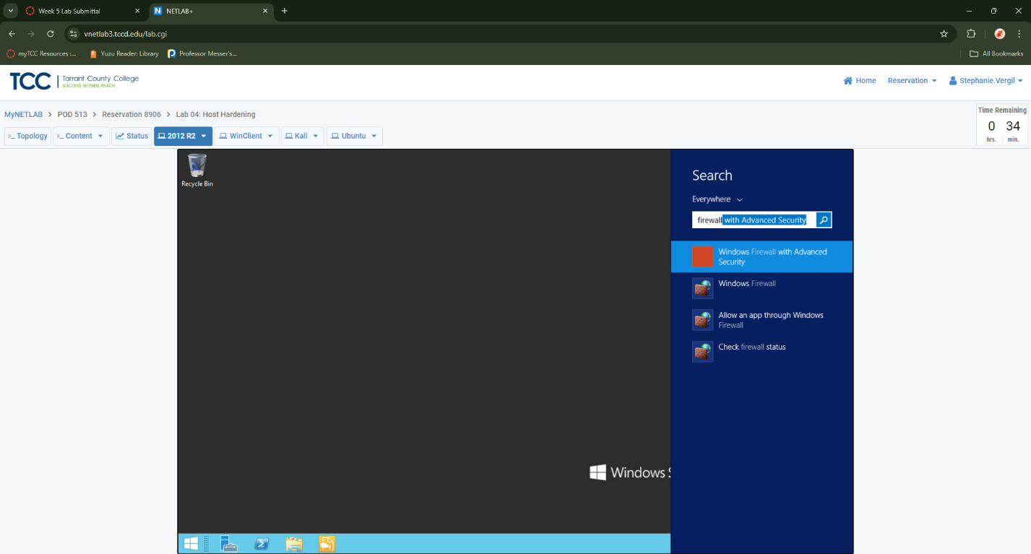

1. Once the Windows Firewall with Advanced Security window loads, click on Inbound Rules in the left pane.
2. Click on New Rule… in the far-right pane

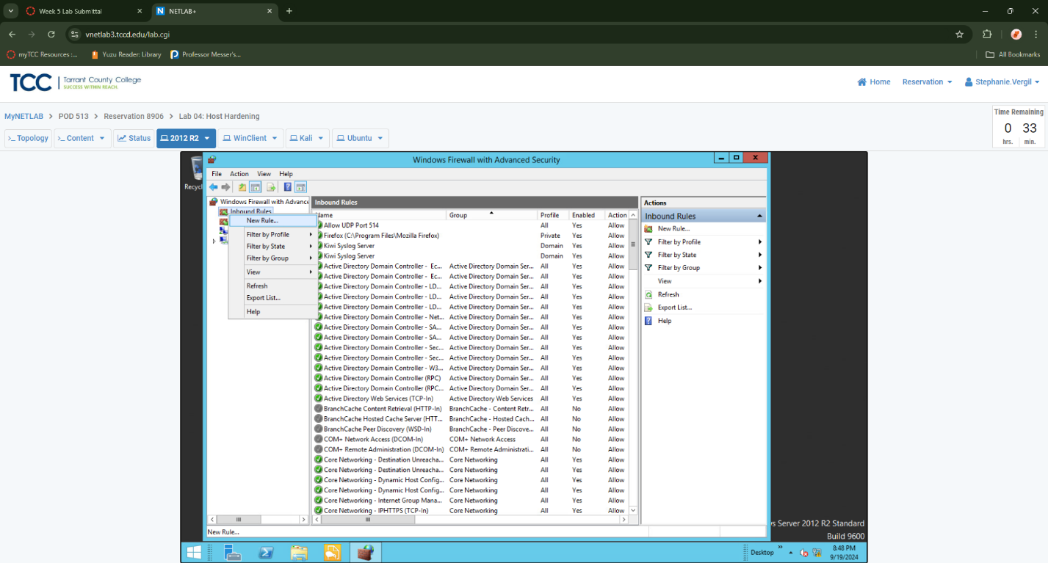

1. In the New Inbound Rule Wizard, click Port, followed by the Next button.
2. Click TCP, followed by Specific local ports. Enter 53, 88 into the field and click Next
3. Click Block the connection, followed by
4. On the following screen, leave all three options checked and click.
5. In the name field, type Block Ports 53 and 88, then click
6. Notice the new rule in the Inbound Rules window.

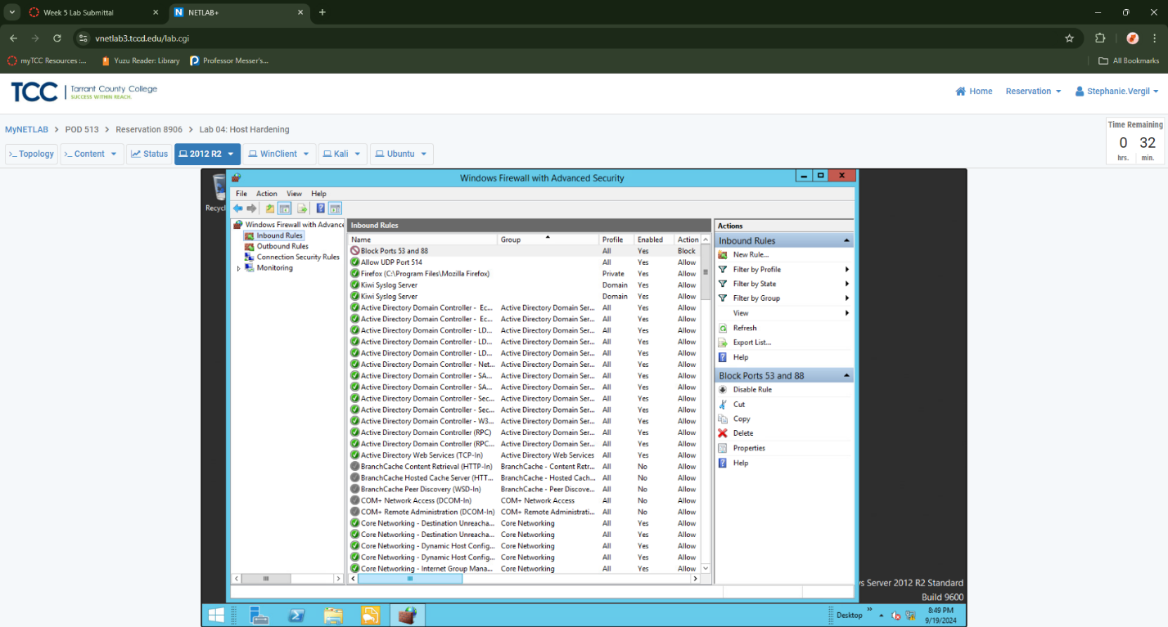

1. Return to the Kali virtual machine.
2. In the Terminal, repeat the following command: nmap -F 192.168.1.2 Notice in the results that ports 53 and 88 are no longer open.

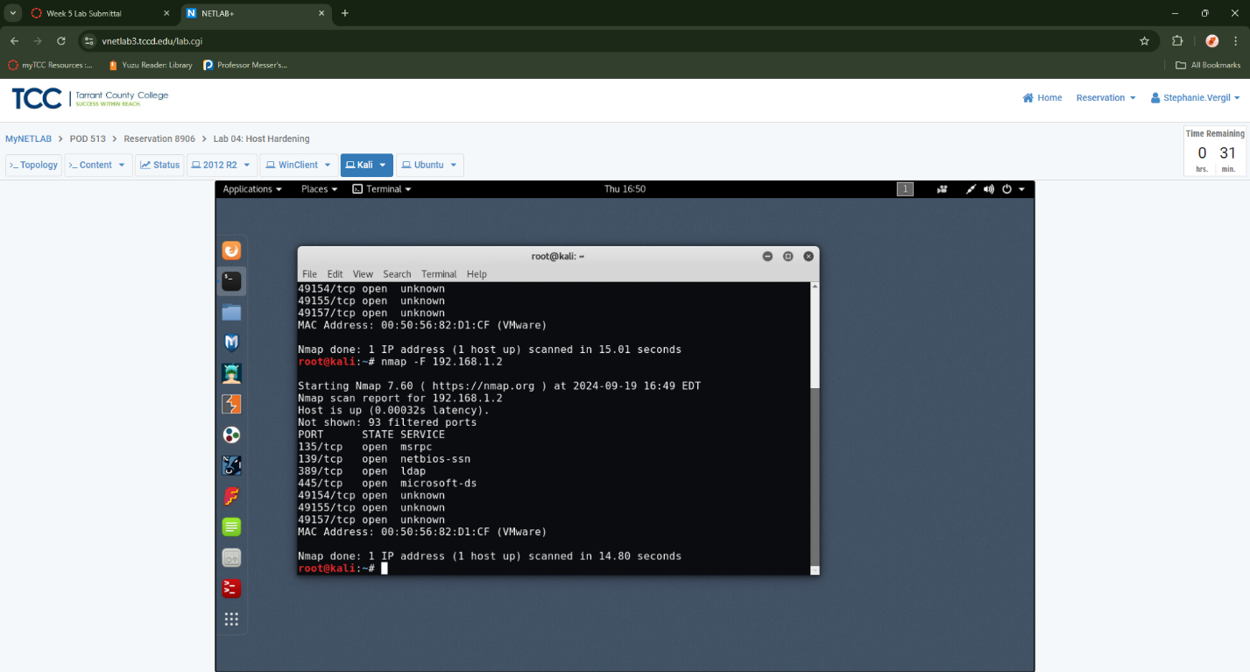

1. Return to the 2012 R2 system and while viewing the Windows Firewall with Advanced Security window, right-click on the Block Ports 53 and 88 rule, and select Disable Rule. Close the Windows Firewall with Advanced Security window.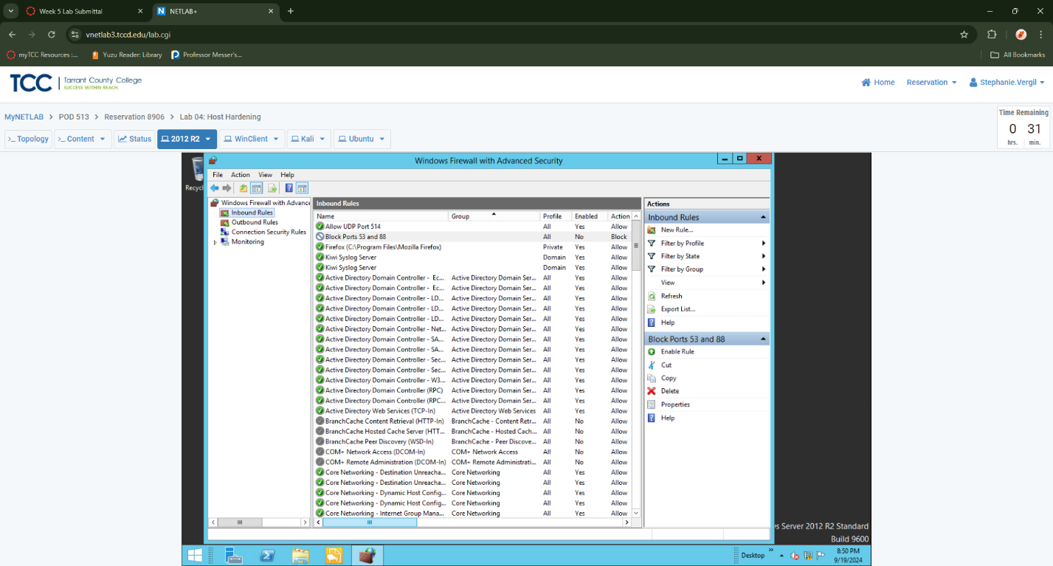
2. Return to the Kali system.
3. Run a scan against the Ubuntu virtual machine by running the following command: nmap -F 192.168.1.4 From the results, you can see that ports 21 (for FTP) and 80 (for HTTP) are open.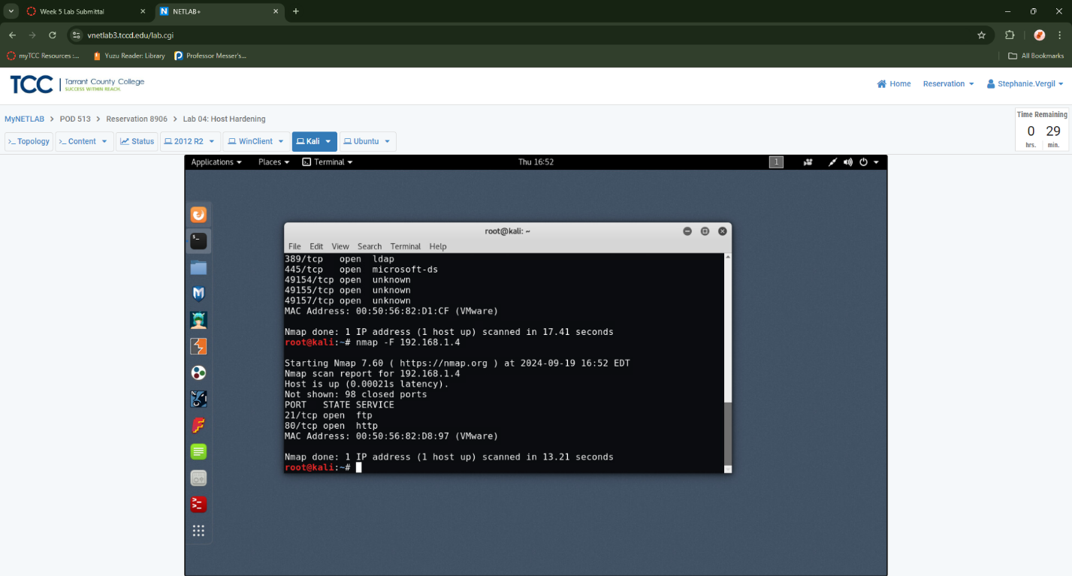
4. Launch the Ubuntu virtual machine to access the graphical login screen.
5. Log in with credentials provided
6. Launch terminal
7. If the FTP port is open on the Ubuntu machine, there is likely a process actively listening on it. To discover what this process is, enter the following command: sudo netstat -tulpn | grep :21

Enter password if prompted. Notice that the process using port 21 is proftpd, also note the PID 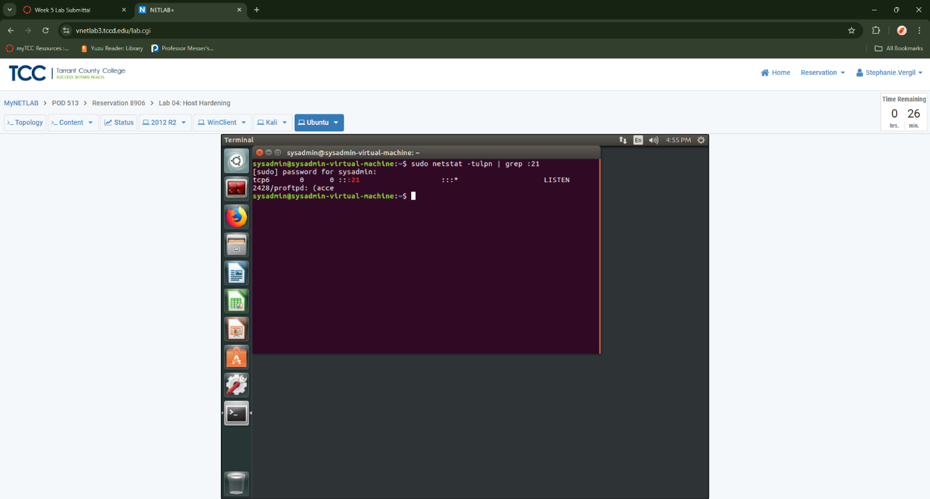

1. To stop this port from listening, kill the process using the PID found in the previous step with the following command: sudo kill 2428

Once finished, close the Terminal window.

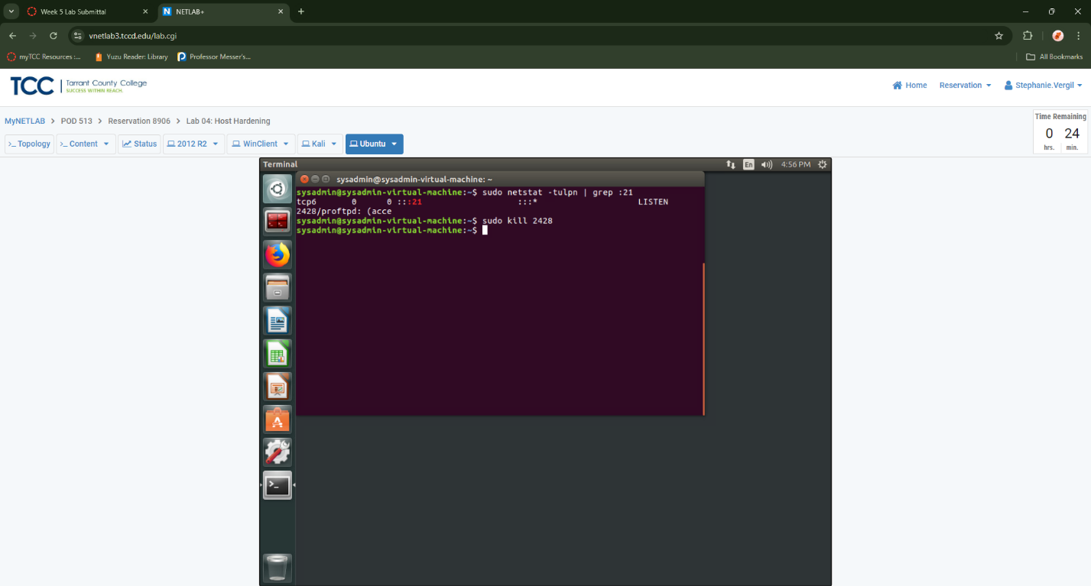

1. Return to the Kali virtual machine.
2. In the Terminal, run the command again: nmap -F 192.168.1.4 on the Ubuntu machine. Notice that port 21 is now closed. You can close the Terminal once you're done reviewing the output.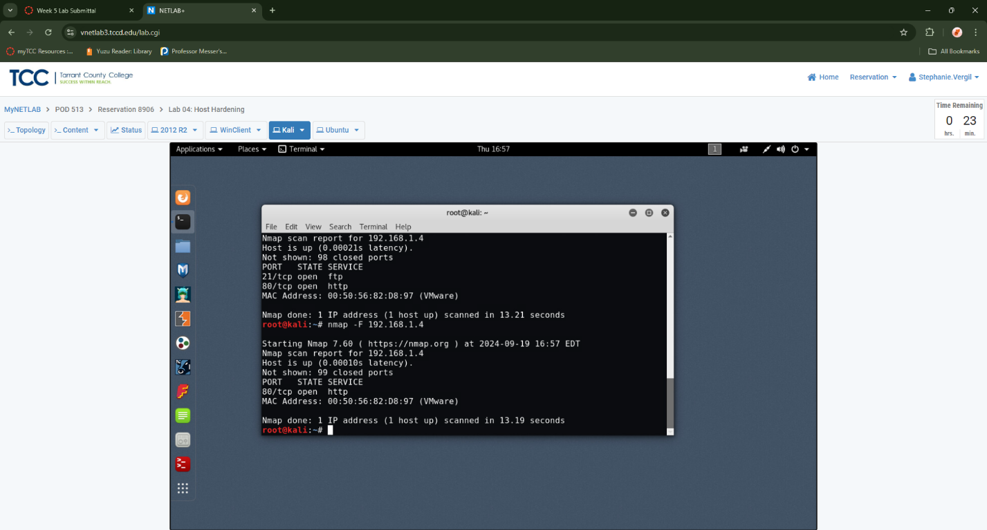
3. Preparing and Applying Patches
4. Return to the 2012 R2 virtual machine.
5. Open the Server Manager. To do this, click the Server Manager icon on the taskbar.
6. In the Server Manager window, click on Manage-> Add Roles and Features

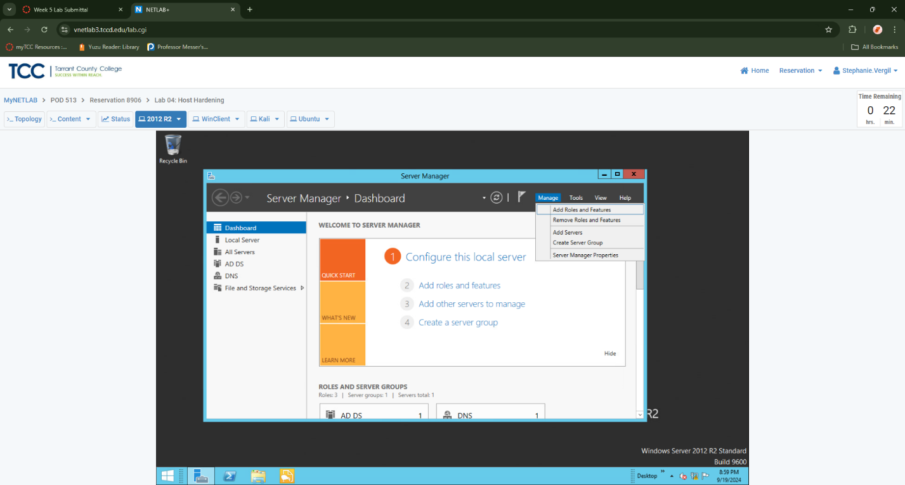

1. On the Before you begin screen, click Next
2. On the Select installation type screen, ensure Role-based or feature-based installation is selected and click Next.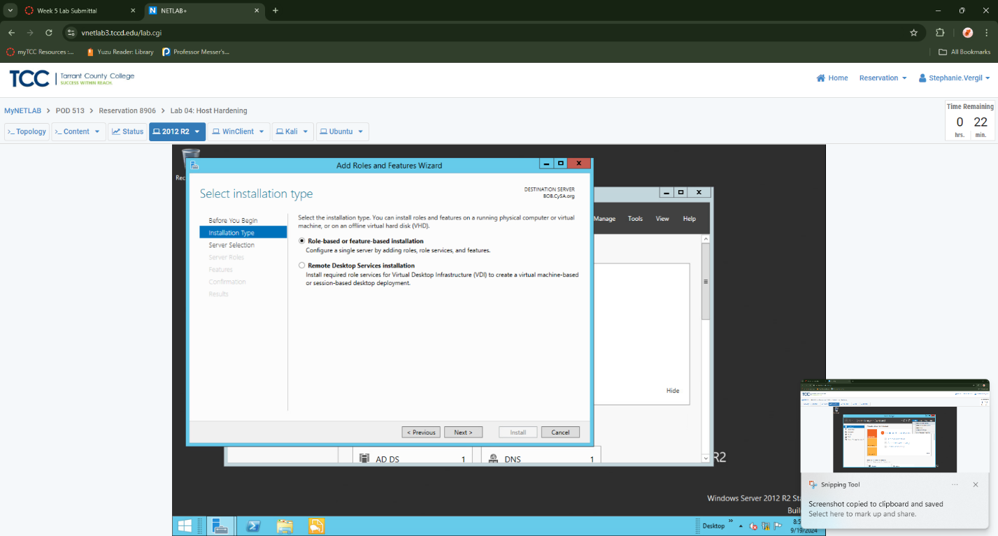
3. On the Select destination server screen, ensure Select a server from the server pool is selected and click Next

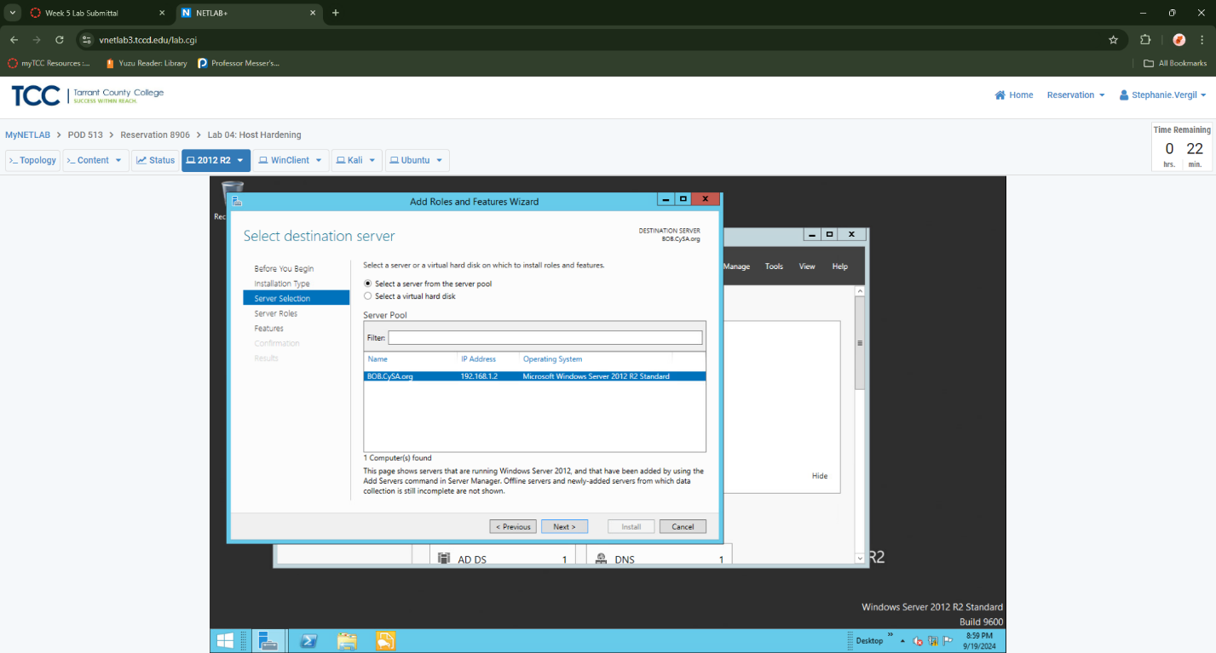

1. On the Select server roles screen, click Next
2. On the Select features screen, select Windows Server Backup and click Next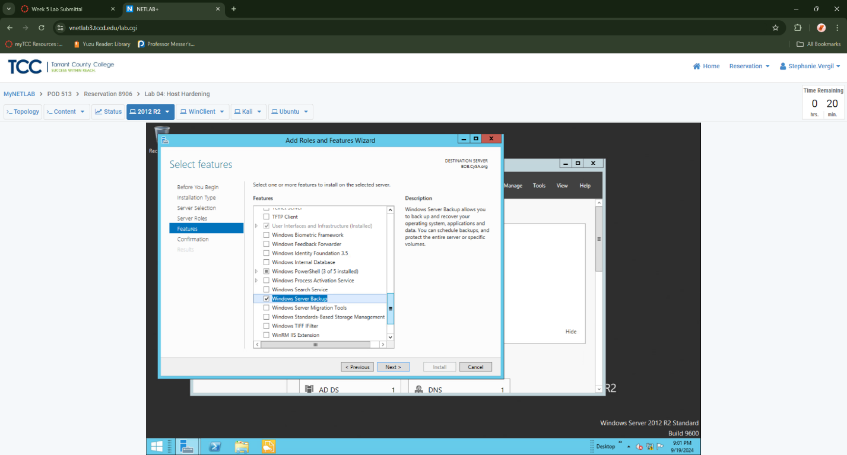
3. On the Confirm installation selections screen, confirm that Windows Server Backup is due to be installed, then click Install
4. Once the installation finishes, close the Installation progress window by clicking Close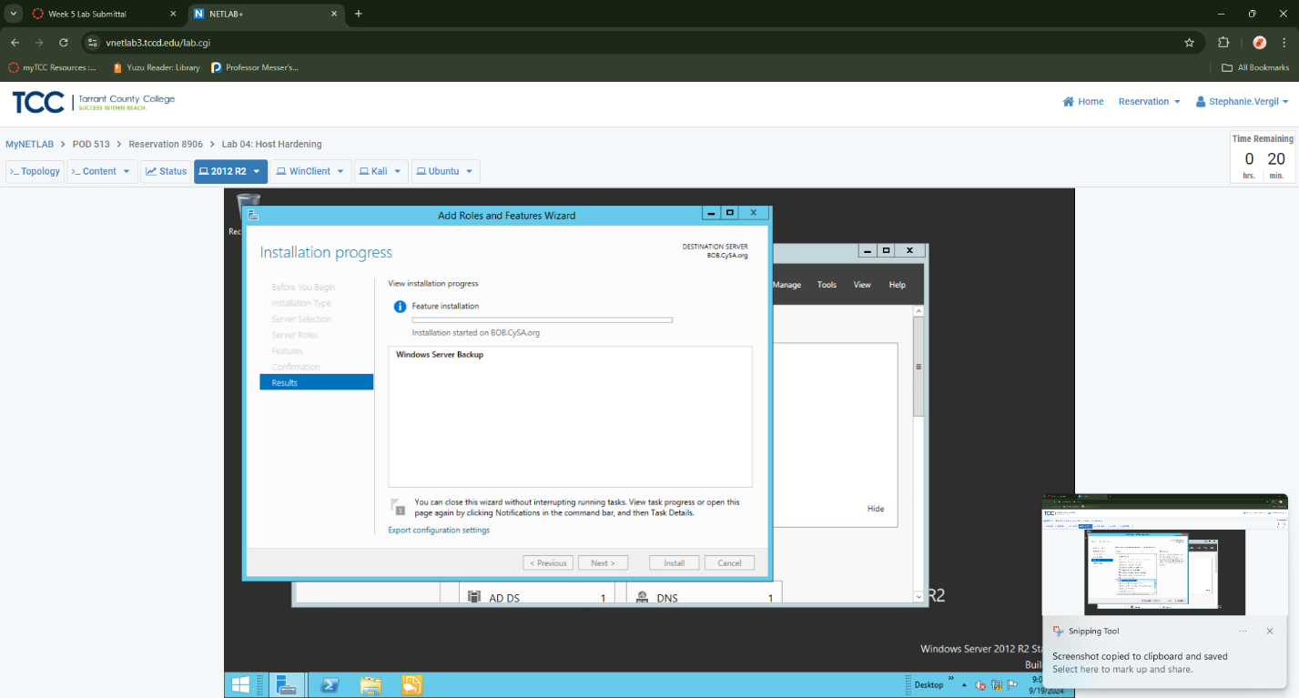
5. Now that Windows Server Backup is installed, you can proceed to create a backup. It is important to maintain fallback points in case an update fails or causes system functions to perform undesirably. To do so, in the Windows Server Manager, click Tools-> Windows Server Backup.

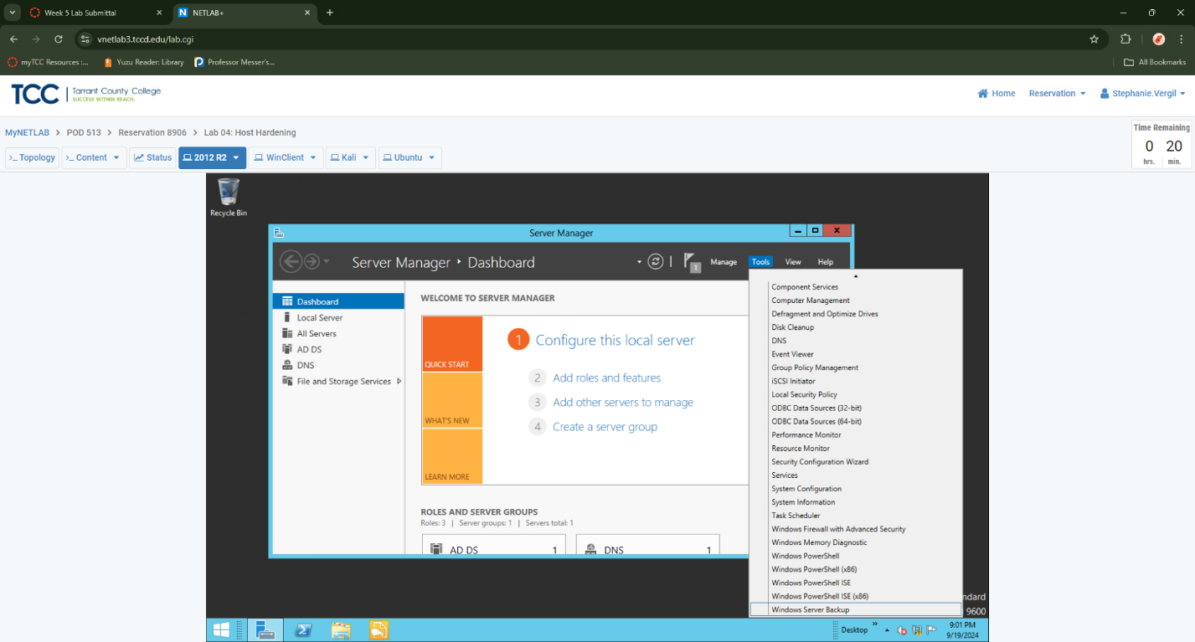

1. In the Windows Server Backup tool, click Local Backup in the left pan
2. Click Backup Once in the Actions pane on the far-right side of your screen.
3. Once the Backup Once Wizard opens, you will be on the Backup Options screen. Confirm that Different options is selected and click Next

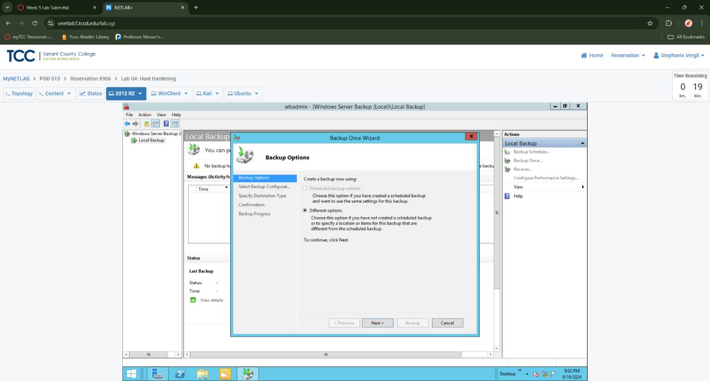

1. On the Select Backup Configuration screen, ensure that Full server (recommended) is selected and click Next.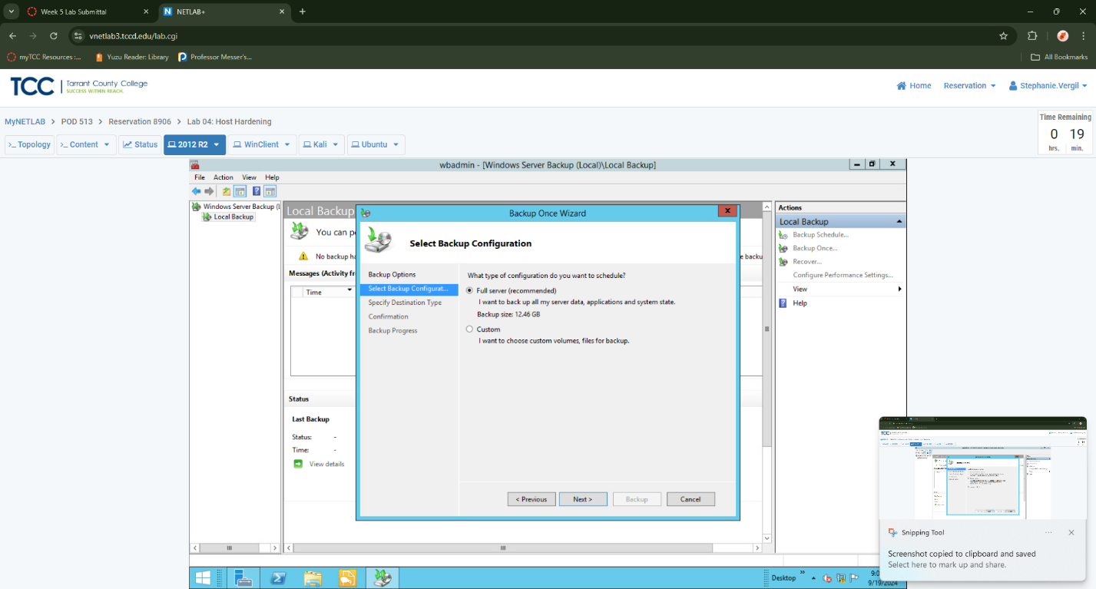
2. On the Specify Destination Type screen, ensure Local drives is selected and click Next.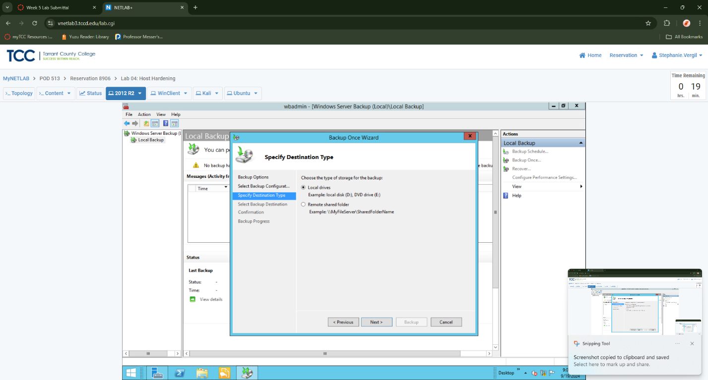
3. On the Select Backup Destination screen, ensure that Backup (E:) is being used as the destination for the backup and click Next.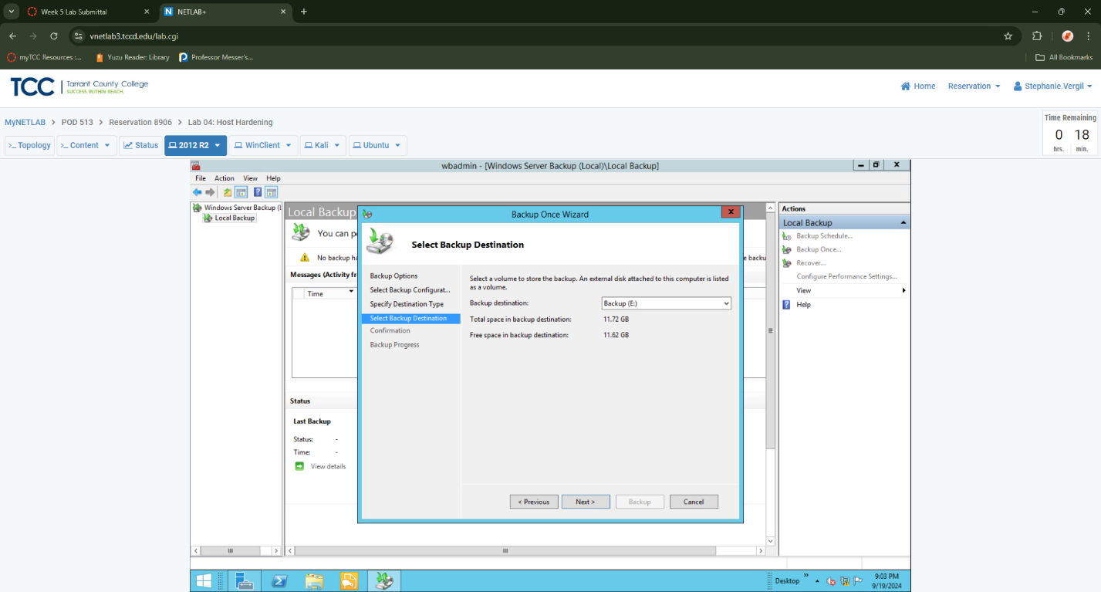
4. You will receive a warning saying that “The selected volume is also included in the list of items to back up.” To prevent this, click OK to remove E: from being backed up into itself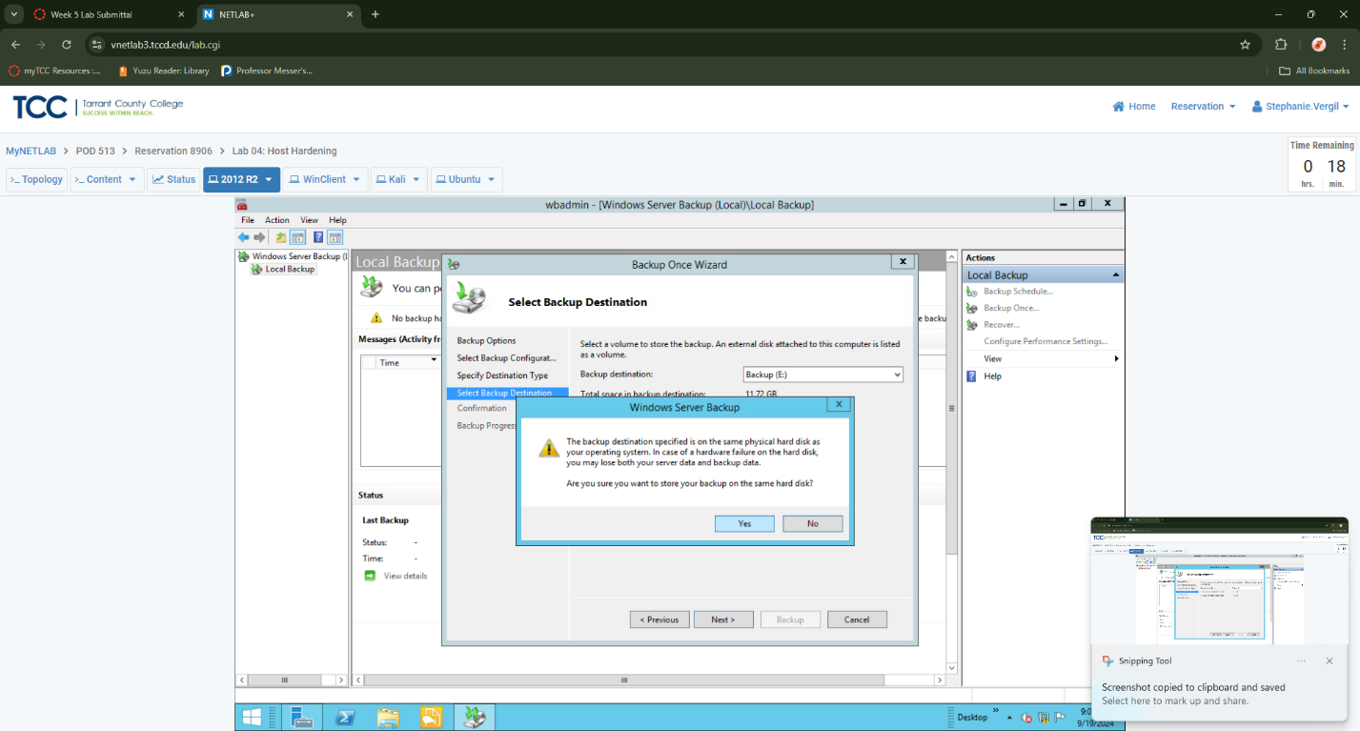
5. You will receive a warning saying that “The backup destination specified is on the same physical hard disk as your operating system. In case of a hardware failure on the hard disk, you may lose both your server data and backup data.” For this lab, disregard this warning and click Yes
6. Confirm the information on the Confirmation screen and click Backup

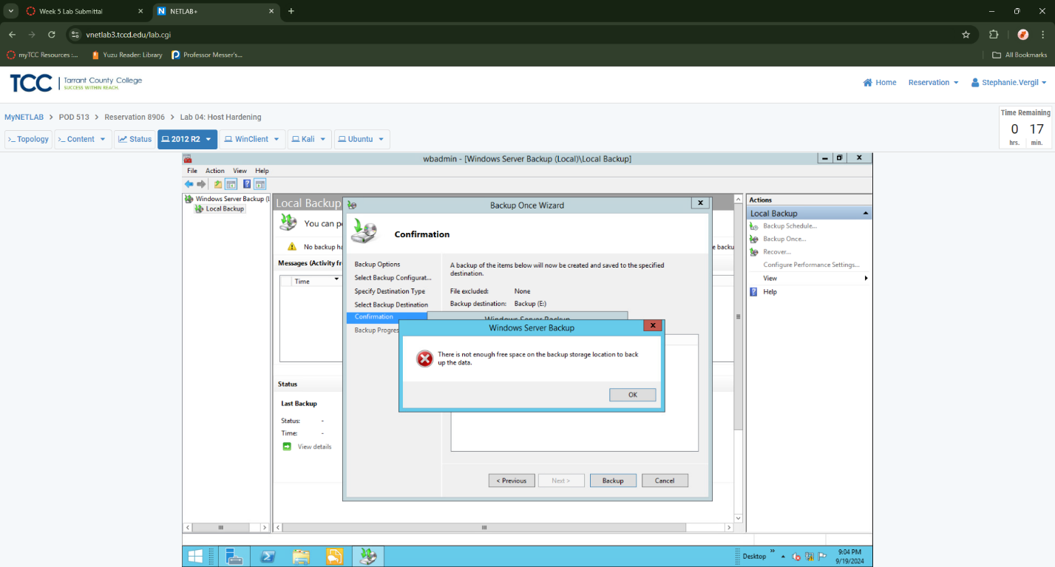

Note: In my case I did have to follow additional steps due to insufficient amount of free space available. If you receive a warning that there is an insufficient amount of free space available to move forward with the backup process, go ahead and clear up some free space by deleting the prtg compressed file found in the C:\Users\Administrator\Documents\LabFiles directory. Make sure to also clear the Recycle Bin afterwards. Then try the backup process again

1. Once the backup finishes, click Close.

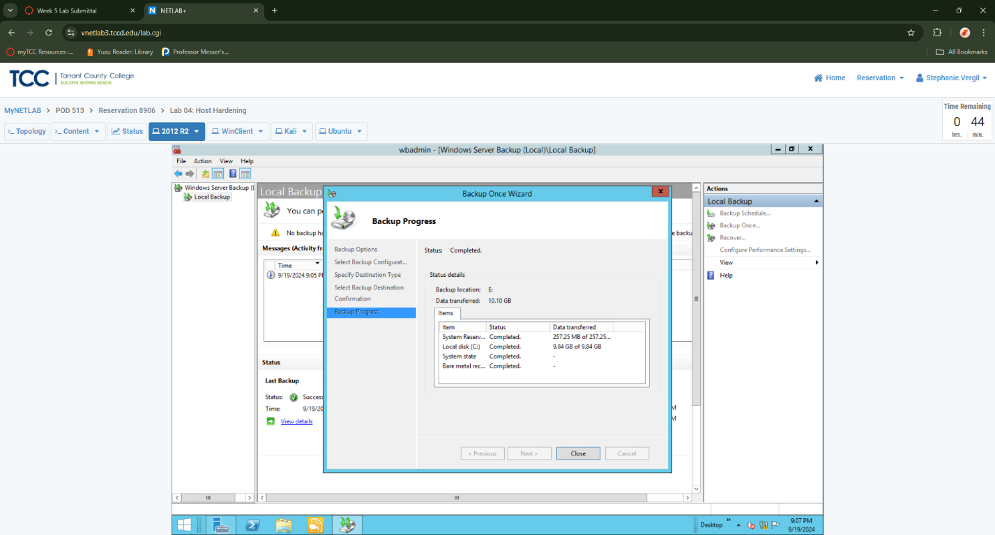

1. Close all open windows. Open a PowerShell window by clicking the icon on the taskbar
2. In the PowerShell prompt, check to see if the update you want to install is currently installed with the following command: Get-Hotfix -id KB2919355 Note that no hotfix can be found, and thus the patch has not yet been installed.

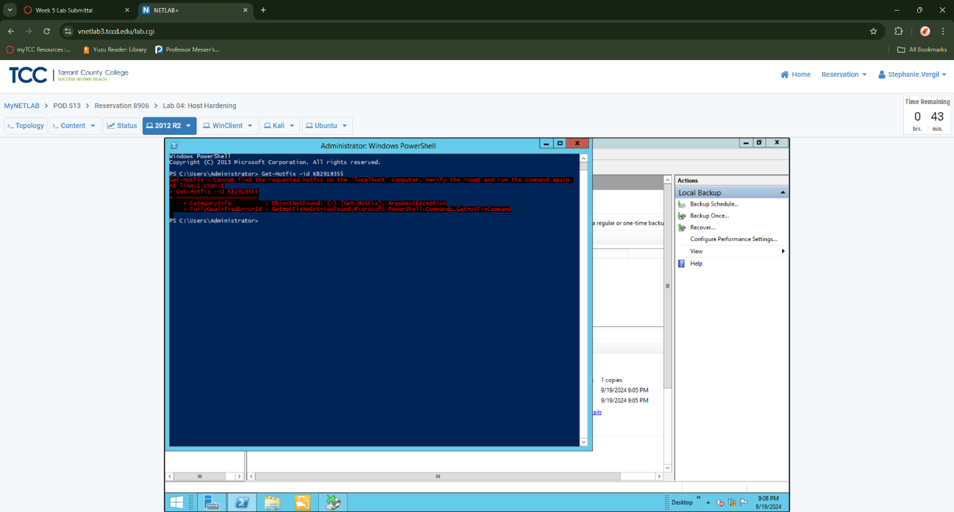

1. To begin the process to install the patch, open the File Explorer by clicking its icon on the taskbar.
2. Navigate to C:\Updates\. Double-click on Windows8.1-KB2919355-x64.msu to install the update you just searched for in PowerShell.
3. You will receive an error message stating that “The update is not applicable to your computer.” This is because this update has a prerequisite that must be installed first. Click OK.

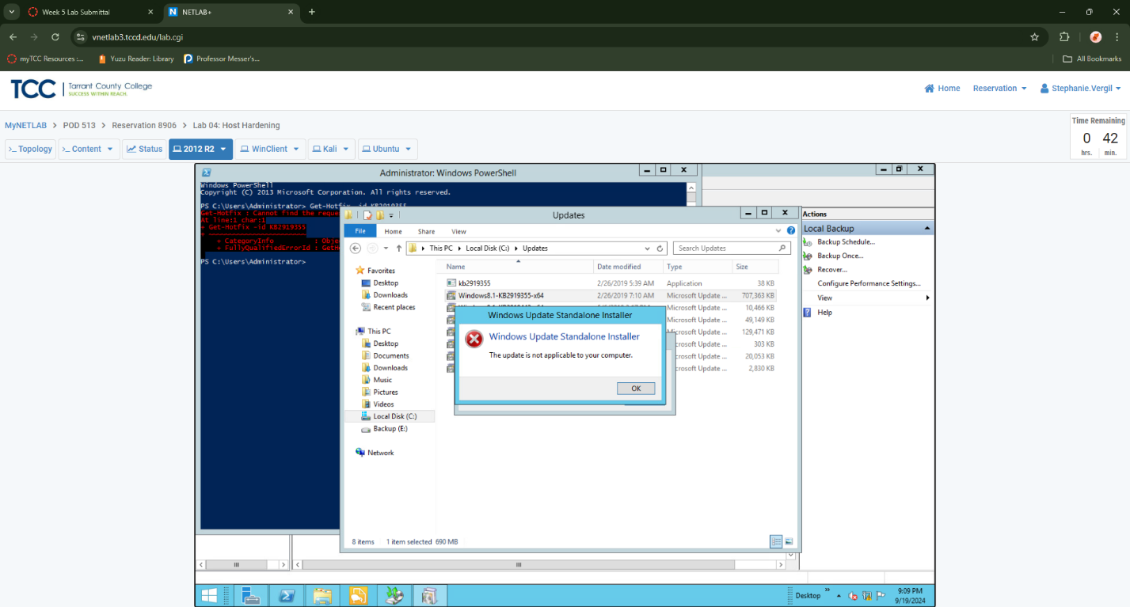

1. To install the prerequisite update, double-click Windows8.1-KB2919442-x64.msu.

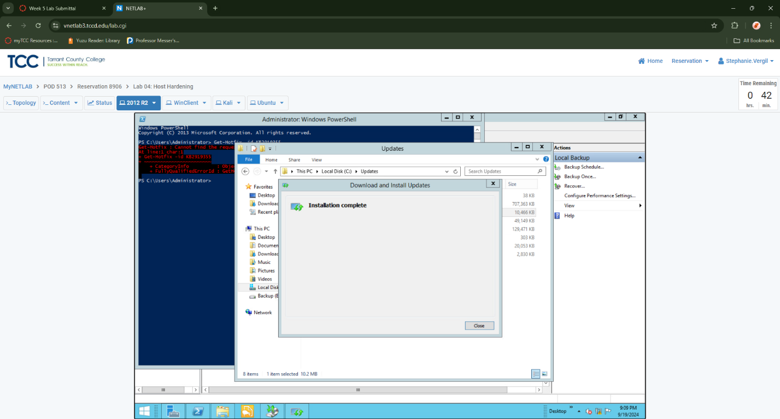

1. When asked to confirm the installation, select Yes
2. Once the update is installed, click Close.
3. Now that you have installed the prerequisite patch, you can install the much larger update. Double-click on Windows8.1- KB2919355-x64 once more and select Yes when prompted.
4. Once the update has installed, you will be prompted to restart the machine. Click Restart Now.

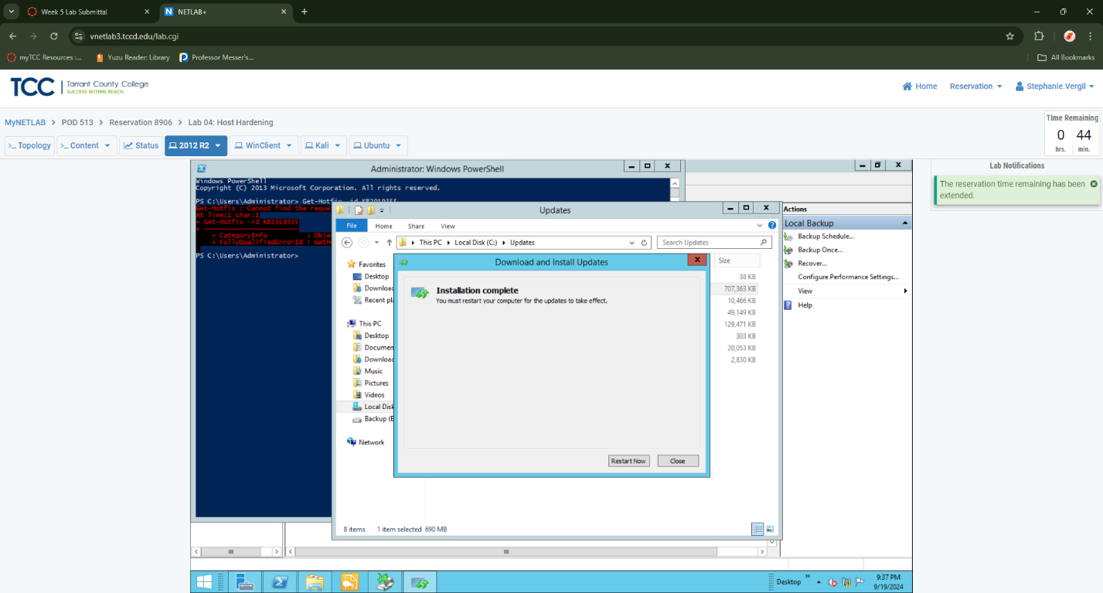

1. Once the machine has restarted, log in as CySa\Administrator using provided credentials.
2. Launch PowerShell
3. To check for the installed update, repeat the command: Get-Hotfix -id KB2919355. Notice now that the update has been installed, different results are received than in step 23. You may now close the PowerShell window.

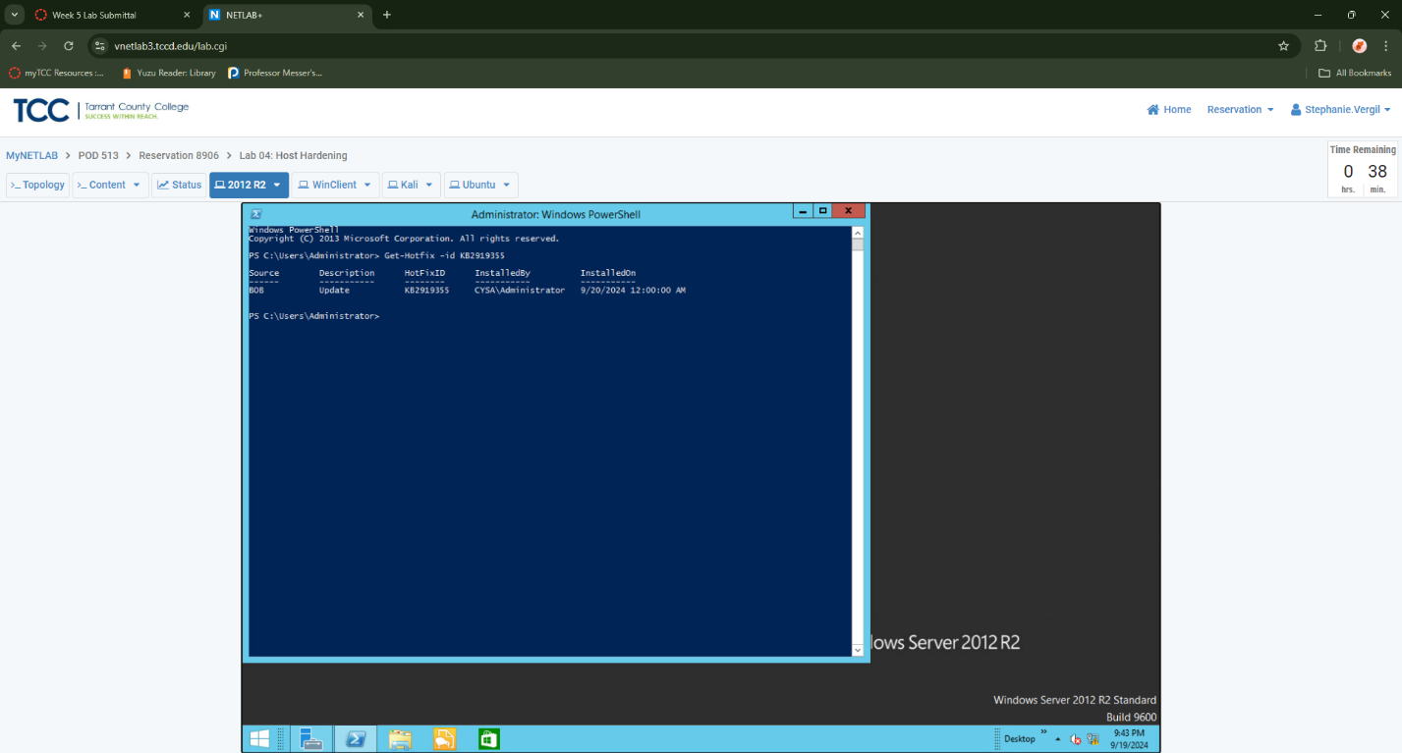

1. Using Windows Defender to Increase Security
2. Launch the WinClient virtual machine to access the graphical login screen
3. Bring up the login window by sending a Ctrl + Alt + Delete.
4. Log in with provided credentials
5. Click the Windows Search icon in the lower-left and type defender.
6. Click on Windows Defender
7. You may be met with a What’s new in Windows Defender window. If so, click Close
8. Once Windows Defender loads click the Turn On button to enable Real-Time Protection.

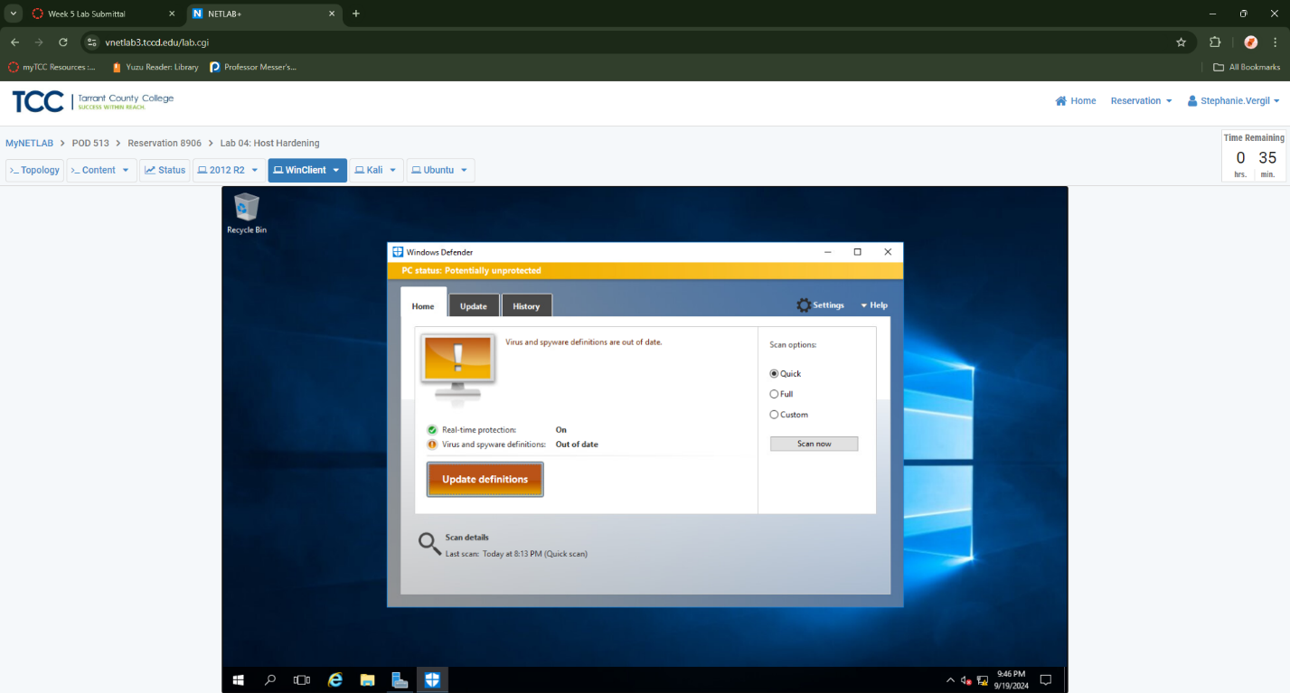

Your Windows Defender may state that your virus and spyware definitions are out of date. You can safely ignore this warning, as the lab environment lacks internet access. This was my case.

1. Next, you will explore various group policy settings related to Windows Defender. Right-click the Windows icon in the lower-left of the screen, then click Run.
2. Type gpmc.msc into the window and click enter
3. In the left pane of the Group Policy Management window, navigate to Forest: CySA.org-> Domains-> CySA.org-> Group Policy Objects.
4. Right-click Group Policy Objects and select New

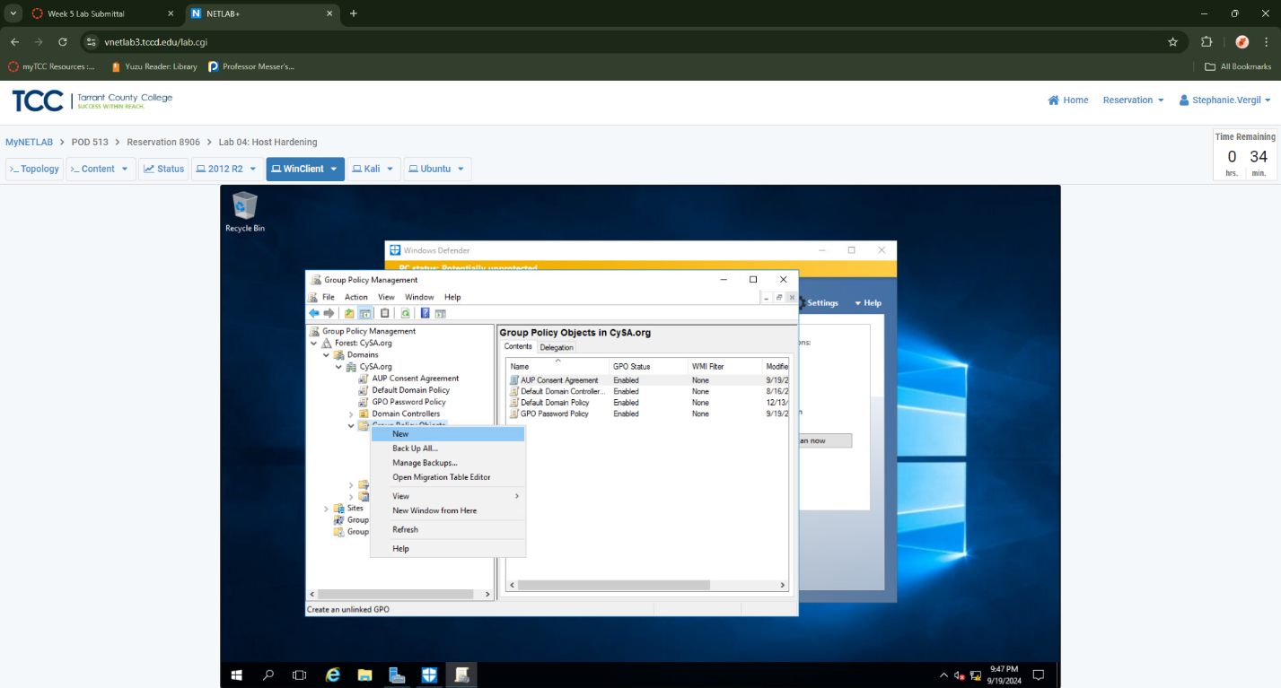

1. In the New GPO window’s Name field, type Windows Defender Policy and click OK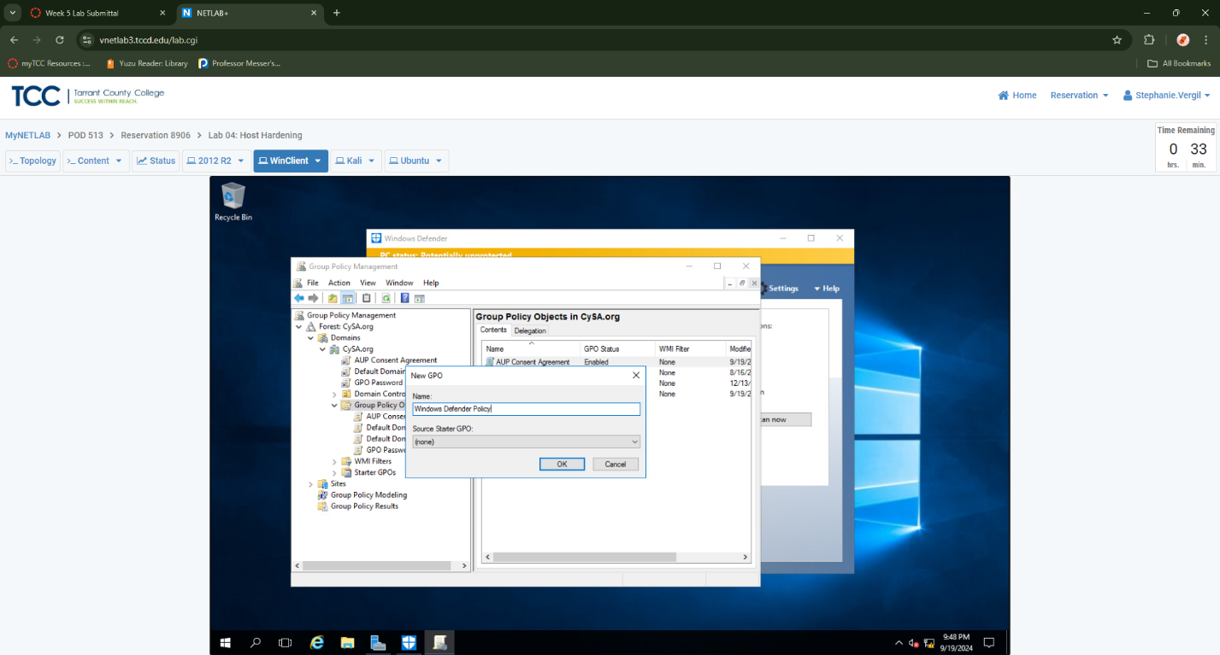
2. Right-click Windows Defender Policy and click Edit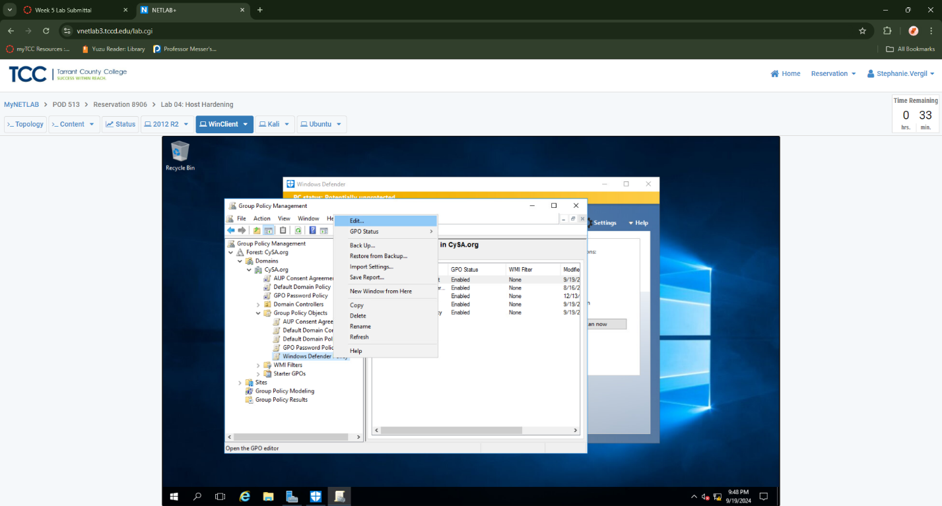
3. In the left pane of the Group Policy Management Editor, expand Computer Configuration-> Policies-> Administrative Templates-> Windows Components.
4. Scroll down and expand Windows Defender. Click on Real-Time Protection.
5. In the right pane, right-click Scan all downloaded files and attachments and click Edit.

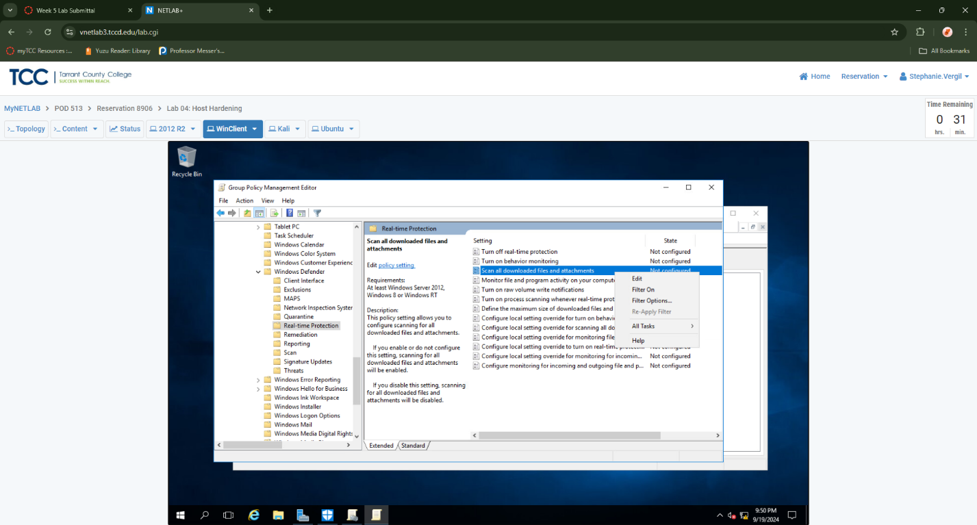

1. Click Enabled and click OK.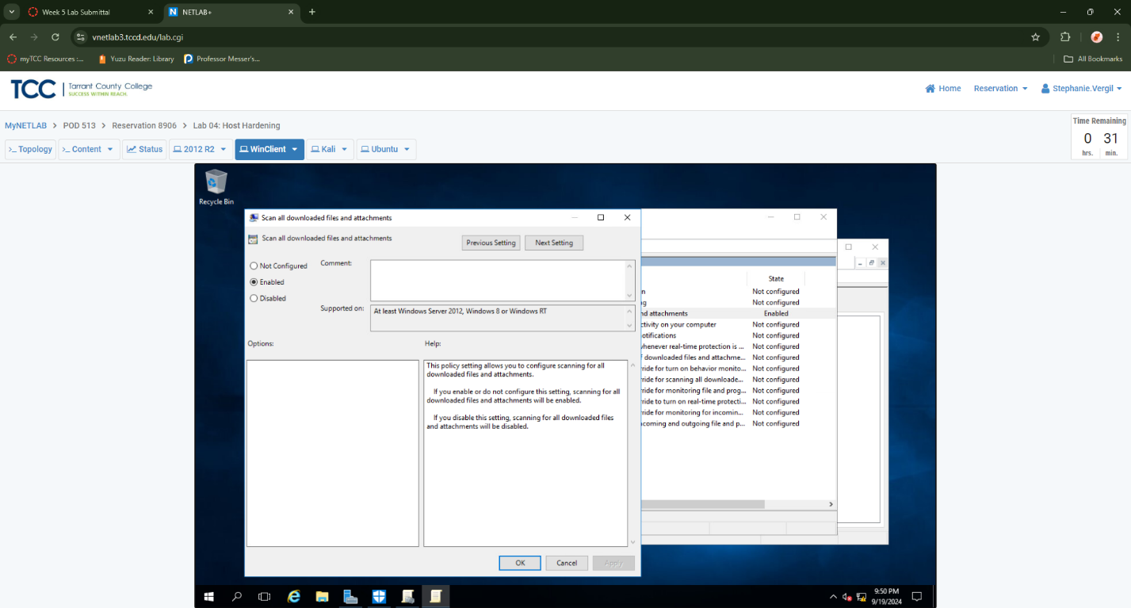
2. On the Windows Group Policy Management Editor, click Scan in the left pane.
3. In the right pane, Right-click on Check for the latest virus and spyware definitions before running a scheduled scan. Click Edit.
4. Click Enabled, then click OK.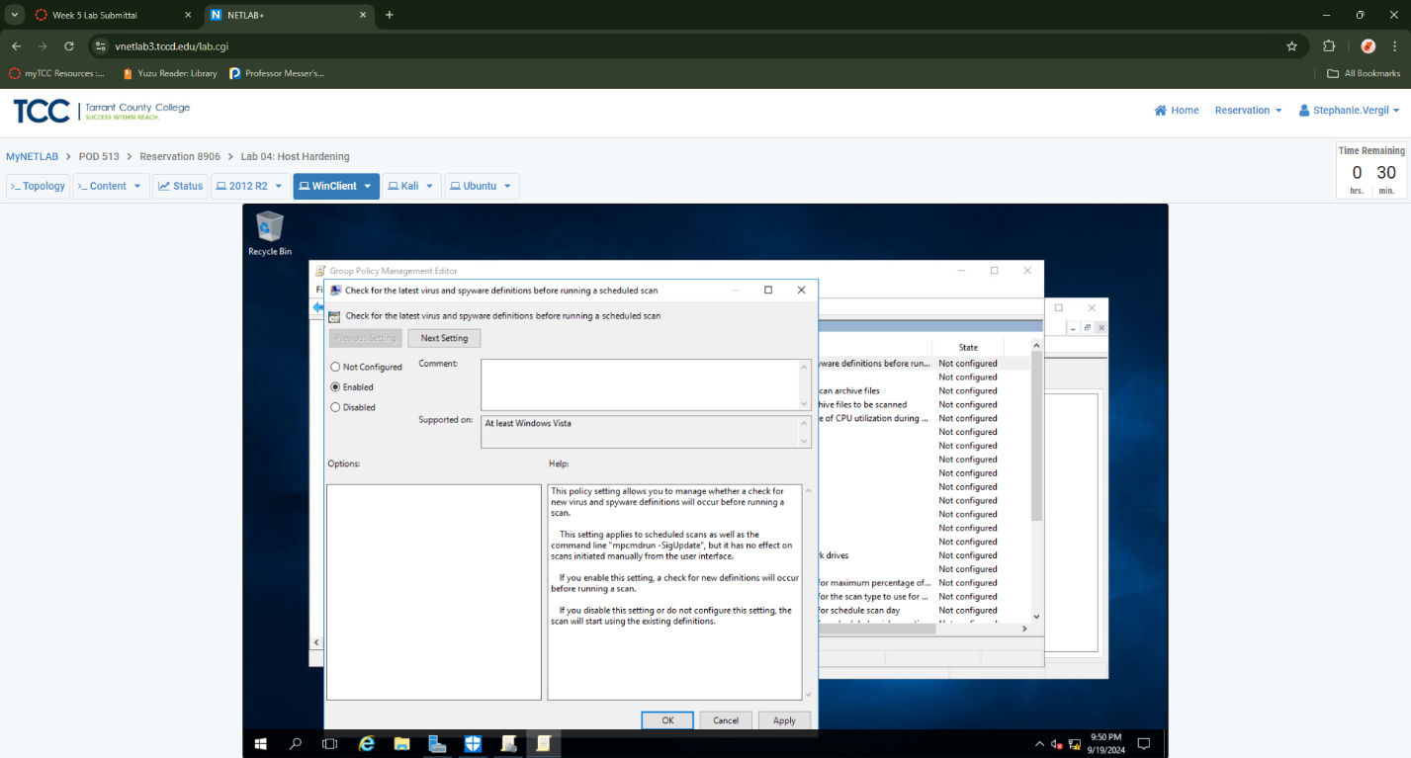
5. Right-click Specify the scan type to use for a scheduled scan. Click Edit
6. Click Enabled. In the drop-down menu, select Full system scan. Click Ok

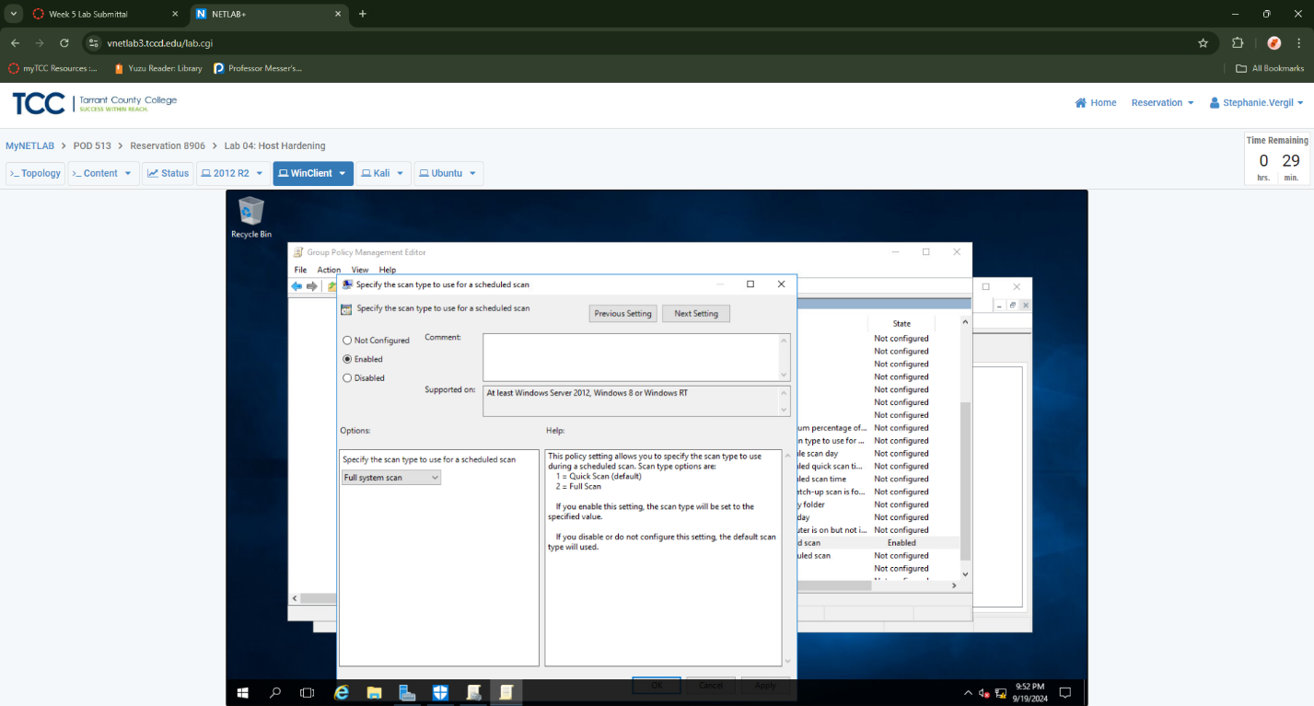

1. Right-click on Specify the day of the week to run a scheduled scan. Click Edit.
2. Click Enabled. In the drop-down menu, select Tuesday. Click OK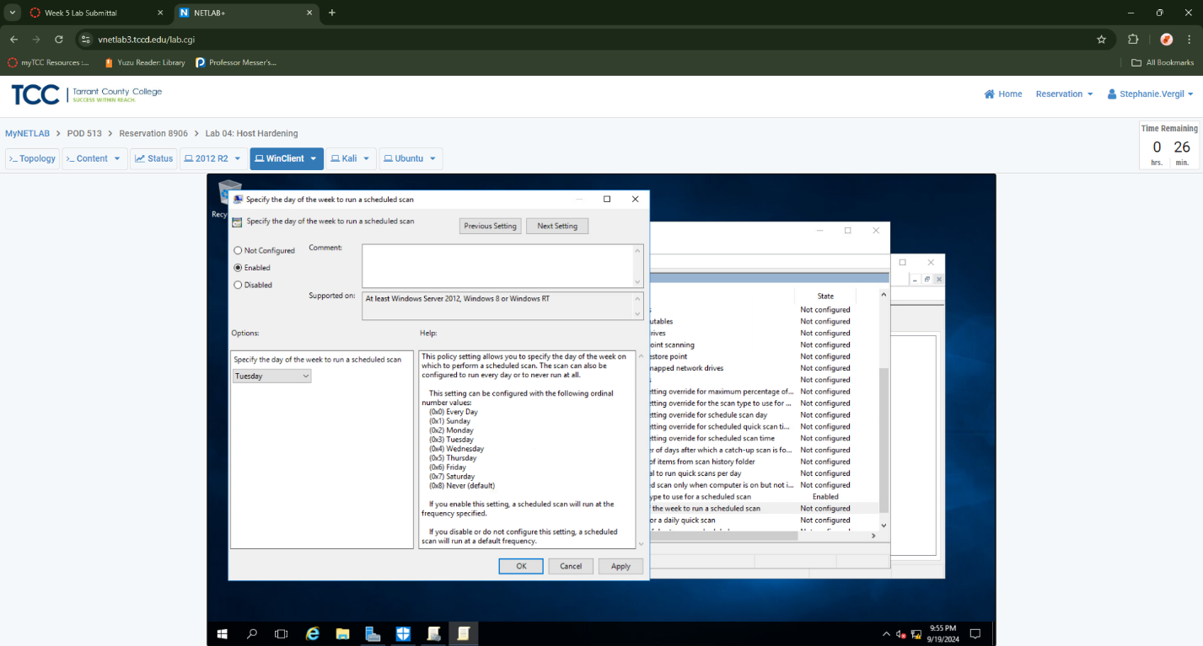
3. Right-click on Specify the time of day to run a scheduled scan. Click Edit.
4. Click Enabled. In the spin box, enter 180. This will tell the scheduler to run a scan at 3:00 AM. Click OK.

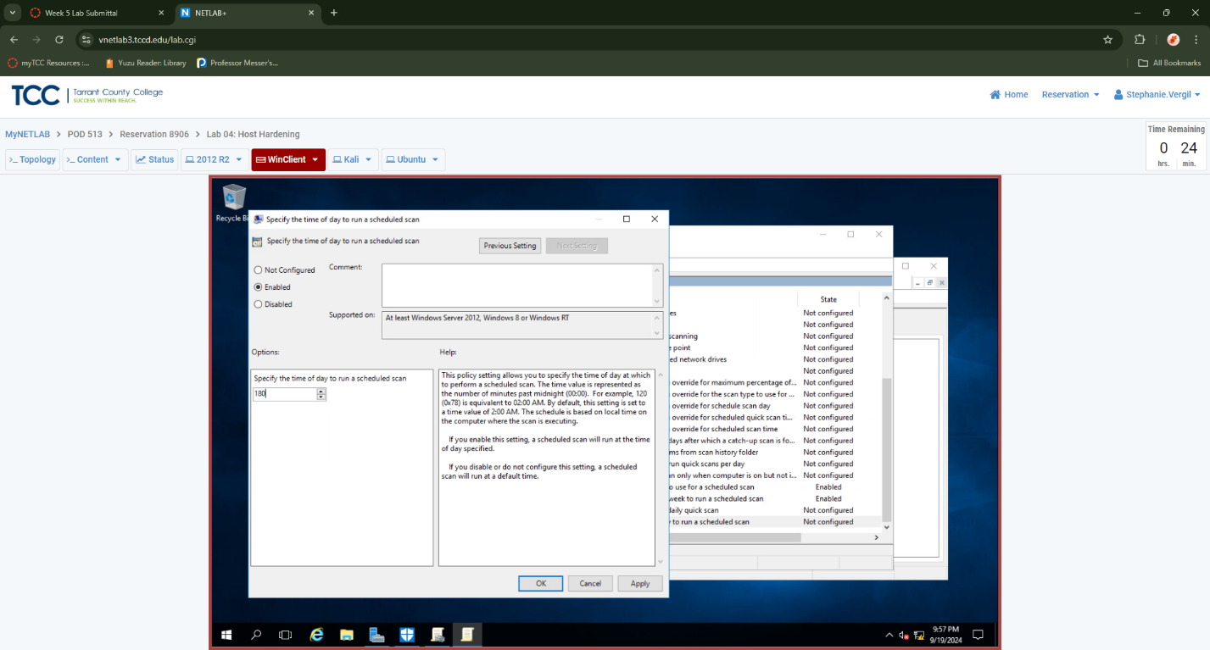

1. You’ve now enabled Windows Defender and configured group policies to run full system scans every Tuesday at 3:00 AM. You’ve also set Windows Defender to scan all downloaded files and update its virus definitions before each weekly scan. This completes the lab.